**ABSTRACT**

In the digital age, the abundance of available books poses a challenge for readers to discover titles that align with their interests. To address this issue, we propose a book recommendation system leveraging Python. Our system utilizes various techniques including natural language processing (NLP), collaborative filtering, and content-based filtering to offer personalized recommendations to users.

We begin by preprocessing and analyzing a dataset comprising book metadata and user interactions. Through exploratory data analysis (EDA), we gain insights into user preferences and book characteristics. We employ NLP techniques to extract meaningful features from book descriptions and user reviews, enabling us to create content-based recommendations based on textual similarity.

Furthermore, we implement collaborative filtering algorithms to identify similar users and recommend books based on their historical interactions. We explore both memory-based (e.g., k-nearest neighbors) and model-based (e.g., matrix factorization) collaborative filtering methods to enhance recommendation accuracy and scalability.

Additionally, we evaluate the performance of our recommendation system using metrics such as precision, recall, and mean average precision. Through experimentation and analysis, we optimize the system parameters to achieve the best possible recommendations.

Finally, we present a user-friendly interface for interacting with the recommendation system, allowing users to receive personalized book suggestions effortlessly. Our system demonstrates the potential of Python-based technologies in building effective and scalable book recommendation solutions tailored to individual preferences.

**INDEX**

|  |  |  |
| --- | --- | --- |
| **CHAPTERS** | **TOPIC** | **PAGE NO.** |
|  | **CERTIFICATE** | **i-ii** |
| **DECLARATION** | **iii** |
| **ACKNOWLEDGEMENT** | **iv** |
| **ABSTRACT** | **v** |
| **INDEX** | **vi- vii** |
| **LIST OF FIGURES** | **viii-ix** |
| **LIST OF TABLES** | **x** |
| **LIST OF ABBERIVIATIONS** | **xi** |
| **CHAPTER 1** | **INTRODUCTION** | **1-8** |
| 1.1 | RELEVENCE OF THE PROJECT | 1 |
| 1.2 | PROBLEM STATEMENT | 1 |
| 1.3 | OBJECTIVES OF THE PROJECT | 2 |
| 1.4  1.5  1.6  1.7  1.8 | SCOPE OF THE PROJECT  METHODOLOGY FOR BOOK RECOMMENDATION  INTRODUCTION TO PYTHON LANGUAGE  INTRODUCTION TO MACHINE LANGUAGE  INTRODUCTION TO ANACONDA AND JUPYTER | 2  2-3  4-5  5-6  6-8 |
| **CHAPTER 2** | **HARDWARE & SOFTWARE REQUIREMENTS** | **9-11** |
| 2.1 | HARDWARE REQUIREMENTS | 9 |
| 2.2 | SOFTWARE REQUIREMENTS | 9--11 |
| **CHAPTER 3** | **SYSTEM ANALYSIS** | **12-14** |
| **CHAPTER 4** | **FEASIBILITY STUDY** | **15-16** |
| 4.1 | TECHNICAL FEASIBILITY | 15 |
| 4.2 | FINANCIAL FEASIBILITY | 15 |
| 4.3 | OPERATIONAL FEASIBILITY | 15 |
| 4.4 | LEGAL AND REGULATORY FEASIBILITY | 16 |
| 4.5 | TIMEFRAME AND MILESTONE | 16 |
| **CHAPTER 5** | **ANALYSIS** | **17-19** |
| 5.1  5.2 | FLOW CHART  BOOK RECOMMENDATION SYSTEM | 17  18 |
| 5.3 | MEMORY BASED CF (L2 DFD) | 18 |
| 5.4 | DFD OF POPULARITY BASED RECOMMENDATION SYSTEM | 19 |
| **CHAPTER 6** | **SOFTWARE ENGINEERING** | **20-23** |
| 6.1 | SOFTWARE DEVELOPMENT LIFE CYCLE | 20 |
| 6.2 | WATERFALL MODEL | 22 |
| **CHAPTER 7** | **SYSTEM DESIGN** | **24-27** |
| 7.1  7.2  7.3  7.4  7.5 | SYSTEM ARCHITECTURE  DATA FLOW  IMPLEMENTATIONDETAILS  SYSTEM SCALABILITY AND PERFORMANCE  SECURITY AND PRIVACY CONSIDERATIONS | 24  25  26  26-27  27 |
| **CHAPTER 8** | **SCREENSHOTS** | **28-34** |
| **CHAPTER 9** | **MODULES OF THE PROJECT** | **35-36** |
| 9.1  9.2  9.3  9.4 | HOME PAGE  POPULARITY BASED RECOMMENDATIONS  COUNTRY BASED RECOMMENDATIONS  AUTHOR BASED BOOK RECOMMENDATIONS | 35  35  36  36 |
| **CHAPTER 10** | **VALIDATION CHECKS** | **37-38** |
| **CHAPTER 11** | **TESTING** | **39-41** |
| **CHAPTER 12** | **IMPLEMENTATION OF PROJECT** | **42-64** |
| 12.1  12.2  12.3  12.4  12.5  12.6 | NUMPY AND ARRAY MANIPULATION  PANDAS DATA MANIPULATION  PYTHON MATPLOTLIB  PYTHON SCKIT-LEARN  PYTHON STREAMLIT  EXPLORATORY DATA ANALYSIS | 42  46  51  58  60  63 |
| **CHAPTER 13** | **SYSTEM SECURITY MEASURES** | **65-67** |
| **CHAPTER 14** | **PERT CHART** | **68-69** |
| **CHAPETR 15** | **FUTURE SCOPE OF THE PROJECT** | **70-72** |
| **CHAPTER 16** | **CONCLUSION** | **73-74** |
| **CHAPTER 17** | **REFERENCES** | **75** |

**LIST OF FIGURES**

|  |  |  |
| --- | --- | --- |
| **FIGURES** | **FIGURES NAME** | **PAGE NO** |
| 1.6.1 | FEATURES OF PYTHON | 3 |
| 1.8.1 | PYTHON AND ANACONDA | 7 |
| 2.1.1 | PYTHON LIBRARIES | 11 |
| 3.1.1 | SYSTEM ANALYSIS | 14 |
| 5.2.1  5.3.1  5.4.1 | BOOK RECOMMENDATION SYSTEM  MEMORY BASED SYSTEM  POPULARITY BASED RECOMMENDATION SYSTEM | 18  19  19 |
| 6.1.1  6.2.2 | SDLC  WATERFALL MODEL | 20  22 |
| 8.1  8.2  8.3  8.4  8.5  8.6  8.7  8.8  8.9  8.10  8.11  8.12  8.13  8.14 | INTRODUCTION PAGE  HOME PAGE OPTIONS  REMOVING NULL VALUES FROM USER DATA  RATING DISTRIBUTION  AGE DISTRIBUTION OF USERS  MOST POPULAR BOOKS  MOST POPULAR AUTHORS  COUNTRIES WITH HIGHEST NUMBER OF USERS  PUBLISHER WITH MOSTE NUMBER OF BOOKS  MERGED DATA  POPULAR BOOK RECOMMENDATIONS  COUNTRY BASED RECOMMENDATIONS  WEIGHTED AVERAGE RATING  AUTHOR BASED BOOK RECOMMENDATIONS | 28  28  29  29  30  30  31  31  32  32  33  33  34  34 |
| 9.1  9.2  9.3  9.4 | HOME PAGE  POPULAR BOOK RECOMMENDATIONS  COUNTRY BASED RECOMMENDATIONS  AUTHOR BASED RECOMMENDATIONS | 35  35  36  36 |
| 11.1 | TESTINGS | 41 |
| 12.1  12.1.2  12.1.3  12.1.4  12.1.5  12.2.1  12.2.2  12.2.3  12.2.4  12.2.5  12.2.6  12.3.1  12.3.2  12.3.3  12.4.1  12.5.1 | PYTHON NUMPY  PANDAS SERIES EXAMPLE 1 PROGRAM  PANDAS SERIES EXAMPLE 1 OUTPUT  PANDAS SERIES EXAMPLE 2 PROGRAM  PANDAS SERIES EXAMPLE 2 OUTPUT  PYTHON PANDAS  PANDAS SERIES EXAMPLE 1  SERIES EXAMPLE 2 PROGRAM  SERIES EXAMPLE 2 OUTPUT  DATAFRAME EXAMPLE 3 PROGRAM  DATAFRAME EXAMPLE 3 OUTPUT  PYTHON MATPLOTLIB  DATA VISUALIZATION FIVE KEY PLOTS  PARTS OF MATPLOTLIB FIGURE  PYTHON SCIKIT LEARN  PYTHON FLASK | 42  44  44  45  46  47  48  49  49  50  50  51  52  53  59  61 |
| 14.1.1 | GANTT CHART | 69 |

**LIST OF TABLES**

|  |  |  |
| --- | --- | --- |
| **TABLES** | **TABLE NAME** | **PAGE NO.** |
| 5.1 | FLOWCHART SYMBOLS | 17 |
| 14.1 | TIMELINE OF ENTIRE PROJECT | 69 |
|  |  |  |
|  |  |  |
|  |  |  |
|  |  |  |

# **LIST OF ABBERIVIATIONS**

|  |  |
| --- | --- |
| ABBREVIATIONS | ACTUAL MEANING |
| NLP | NATURAL LANGUAGE PROCESSING |
| EDA | EXPLORATORY DATA ANALYSIS |
| ML | MACHINE LEARNING |
| DL | DEEP LEARNING |
| AI | ARTIFICIAL INTELLIGENCE |
| DFD | DATA FLOW DIAGRAM |
| DNN | CLASSIC DEEP NEURAL NETWORK |
| RNN | RECURRENT NEURAL NETWORK |
| K-NN | K-NEAREST NEIGHBORS |
| CRA | CLASSICAL RECOMMENDATION ALGORITHMS |
| CF | COLLABORATIVE FILTERING |
| CSV | COMMA-AEPARATED VALUES |

# **CHAPTER 1**

# **INTRODUCTION**

In today's digital age, recommendation systems have emerged as crucial tools for guiding users through vast repositories of content. Whether it's movies, music, books, or other products, recommendation engines leverage user data to predict preferences and offer personalized suggestions. These systems play a pivotal role in enhancing user experience and driving engagement across various platforms.

Books, like movies, encompass a diverse array of genres and topics, catering to varied interests and preferences. From educational materials to fiction and non-fiction, books offer a wealth of content waiting to be explored. However, the sheer volume of available books can overwhelm readers, making it challenging to discover titles aligned with their tastes. A robust book recommendation system addresses this challenge by analyzing user behavior and preferences to deliver tailored book suggestions, thereby streamlining the book discovery process.

**1.1 RELEVANCE OF THE PROJECT**

A book recommendation system serves as a valuable tool for guiding readers through the vast landscape of available literature. By leveraging user preferences and book characteristics, such systems streamline the book discovery process, offering personalized recommendations tailored to individual tastes. In an age where time is of the essence, an efficient recommendation system can significantly enhance the reading experience by facilitating the discovery of relevant and engaging books.

**1.2 PROBLEM STATEMENT**

The primary challenge addressed by the project is the difficulty faced by readers in discovering books that align with their interests amidst the extensive collection of available titles. Traditional methods of book discovery, such as browsing through libraries or online bookstores, often prove time-consuming and inefficient. A sophisticated book recommendation system is needed to analyze user preferences and recommend books that match their tastes, thereby enhancing the overall reading experience.

**1.3 OBJECTIVE OF THE PROJECT**

The main objective of the project is to develop a book recommendation system that accurately predicts user preferences and provides personalized recommendations. Specifically, the project aims to:

Enhance the efficiency of book discovery by offering tailored recommendations based on user preferences.

Improve user engagement and satisfaction by delivering relevant and engaging book suggestions.

Explore and implement advanced algorithms and techniques to enhance the accuracy and effectiveness of the recommendation system.

**1.4 SCOPE OF THE PROJECT**

The scope of the project encompasses the development of a comprehensive book recommendation system capable of analyzing user preferences and book characteristics to generate personalized recommendations. The system will utilize a combination of content-based and collaborative filtering techniques to enhance recommendation accuracy and relevance. Additionally, the project will explore methods for addressing scalability issues to accommodate growing user bases and expanding book collections.

**1.5 METHODOLOGY FOR BOOK RECOMMENDATION**

The methodology for developing the book recommendation system involves several key steps:

* **Data Collection:** Gathering relevant datasets containing book metadata, user interactions, and other relevant information.
* **Data Preprocessing:** Cleaning and preprocessing the collected data to ensure data quality and consistency.
* **Algorithm Selection:** Choosing appropriate recommendation algorithms, such as collaborative filtering and content-based filtering, based on the characteristics of the dataset and project requirements.
* **Model Training and Evaluation:** Training the recommendation model using the selected algorithms and evaluating its performance using metrics such as accuracy, precision, and recall.
* **Integration and Deployment:** Integrating the recommendation system into a user-friendly interface and deploying it for real-world usage.

**1.6 INTRODUCTION TO PYTHON LANGUAGE**

Python is developed by **Guido van Rossum**. Guido van Rossum started implementing Python in 1989. Python is a very simple programming language so even if you are new to programming, you can learn python without facing any issues. Interesting fact: Python is named after the comedy television show Monty Python’s Flying Circus. It is not named after the Python snake.

### 

**Figure 1.6.1** Features Of Python Language

### **1.6.1 Features of Python language**

* **Readable:** Python is a very readable language.m
* **Easy to Learn:** Learning python is easy as this is an expressive and high-level programming language, which means it is easy to understand the language and thus easy to learn.
* **Cross platform:** Python is available and can run on various operating systems such as Mac, Windows, Linux, Unix etc. This makes it a cross platform and portable language.
* **Open Source:** Python is an open-source programming language.
* **Large standard library:** Python comes with a large standard library that has some handy codes and functions which we can use while writing code in Python.
* **Free:** Python is free to download and use. This means you can download it for free and use it in your application. See: Open-Source Python License.
* **Supports exception handling:** If you are new, you may wonder what is an exception? An exception is an event that can occur during program exception and can disrupt the normal flow of program. Python supports exception handling which means we can write less error prone code and can test various scenarios that can cause an exception later on.
* **Advanced features:** Supports generators and list comprehensions. We will cover these features later.
* **Automatic memory management:** Python supports automatic memory management which means the memory is cleared and freed automatically. You do not have to bother clearing the memory.

### **1.6.2 What you can do with Python?**

You may be wondering what all the applications of Python are. There are so many applications of Python, here are some of the them.

* **Web development –** Web framework like Django and Flask are based on Python. They help you write server-side code which helps you manage database, write backend programming logic, mapping URLs etc.
* **Machine learning –** There are many machine learning applications written in Python. Machine learning is a way to write a logic so that a machine can learn and solve a particular problem on its own. For example, products recommendation in websites like Amazon, Flipkart, eBay etc. is a machine learning algorithm that recognizes user’s interest. Face recognition and Voice recognition in your phone is another example of machine learning.
* **Data Analysis –** Data analysis and data visualization in form of charts can also be developed using Python.
* **Scripting –** Scripting is writing small programs to automate simple tasks such as sending automated response emails etc. Such type of applications can also be written in Python programming language
* **Game development –** You can develop games using Python
* You can develop **Embedded applications** in Python
* **Desktop applications –** You can develop desktop application in Python using library like TKinter or QT.

## INTRODUCTION TO MACHINE LEARNING

Machine Learning is the field of study that gives computers the capability to learn without being explicitly programmed. ML is one of the most exciting technologies that one would have ever come across. As it is evident from the name, it gives the computer that makes it more similar to humans: The ability to learn. Machine learning is actively being used today, perhaps in many more places than one would expect.

Machine learning refers to the general use of algorithms and data to create autonomous or semi-autonomous machines.

### **1.7.1 Types of machine learning**

* **Unsupervised learning:** Unsupervised machine learning uses unlabeled data sets to train algorithms. In this process, the algorithm is fed data that doesn't include tags, which requires it to uncover patterns on its own without any outside guidance. For instance, an algorithm may be fed a large amount of unlabeled user data culled from a social media site in order to identify behavioral trends on the platform. Unsupervised machine learning is often used by researchers and data scientists to identify patterns within large, unlabeled data sets quickly and efficiently.
* **Supervised learning:** In supervised machine learning, algorithms are trained on labeled data sets that include tags describing each piece of data. In other words, the algorithms are fed data that includes an “answer key” describing how the data should be interpreted. For example, an algorithm may be fed images of flowers that include tags for each flower type so that it will be able to identify the flower better again when fed a new photograph. Supervised machine learning is often used to create machine learning models used for prediction and classification purposes.
* **Semi supervised learning:** Semi-supervised machine learning uses both unlabeled and labeled data sets to train algorithms. Generally, during semi-supervised machine learning, algorithms are first fed a small amount of labeled data to help direct their development and then fed much larger quantities of unlabeled data to complete the model. For example, an algorithm may be fed a smaller quantity of labeled speech data and then trained on a much larger set of unlabeled speech data in order to create a machine learning model capable of speech recognition. Semi-supervised machine learning is often employed to train algorithms for classification and prediction purposes in the event that large volumes of labeled data is unavailable.
* **Reinforcement learning:** Reinforcement learning uses trial and error to train algorithms and create models. During the training process, algorithms operate in specific environments and then are provided with feedback following each outcome. Much like how a child learns, the algorithm slowly begins to acquire an understanding of its environment and begins to optimize actions to achieve particular outcomes. For instance, an algorithm may be optimized by playing successive games of chess, which allows it to learn from its past successes and failures playing each game. Reinforcement learning is often used to create algorithms that must effectively make sequences of decisions or actions to achieve their aims, such as playing a game or summarizing an entire text.

1.8 INTRODUCTION TO ANACONDA AND JUPYTER NOTEBOOK

Anaconda is a powerful open-source distribution of the Python and R programming languages, designed specifically for data science and machine learning tasks. It was developed and is maintained by Anaconda, Inc. With Anaconda, users can easily manage packages, environments, and dependencies, making it a popular choice for data scientists, researchers, and developers alike.

**1.8.1 Features of Anaconda:**

* **Package Management:** Anaconda comes with a user-friendly package manager called Conda, which allows users to easily install, update, and manage packages and dependencies. This simplifies the process of setting up and maintaining a data science environment.
* **Environment Management:** Anaconda enables users to create isolated Python environments with different versions of Python and different sets of packages. This helps in managing dependencies and ensures reproducibility across different projects.
* **Comprehensive Libraries:** Anaconda includes a wide range of popular data science libraries and tools such as NumPy, pandas, scikit-learn, TensorFlow, and PyTorch, making it a comprehensive solution for data analysis, machine learning, and scientific computing.
* **Cross-Platform:** Anaconda is available for Windows, macOS, and Linux, making it suitable for users on various operating systems.
* **Integrated Development Environments (IDEs):** Anaconda seamlessly integrates with popular IDEs like Jupyter Notebook, Spyder, and VS Code, providing users with a choice of development environments tailored to their preferences and workflows.

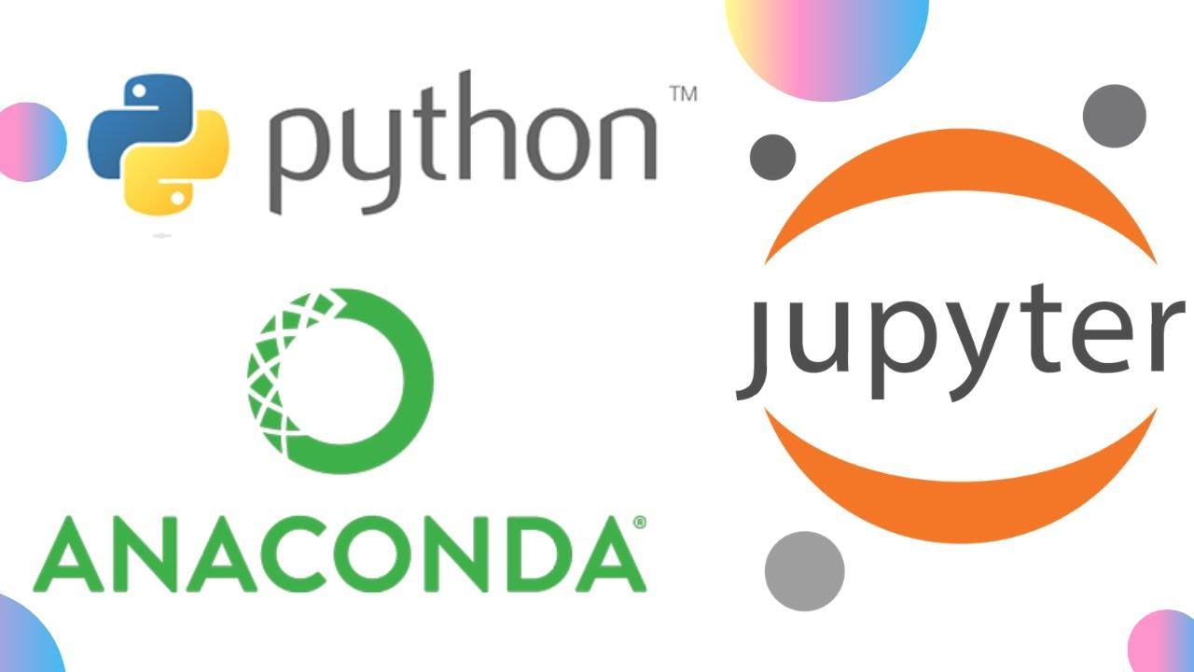

**Figure 1.8.1** Anaconda And Jupyter Notebook

**1.8.2 Introduction to Jupyter Notebook:**

Jupyter Notebook is an open-source web application that allows users to create and share documents containing live code, equations, visualizations, and narrative text. Originally developed as part of the IPython project, Jupyter Notebook supports various programming languages, including Python, R, Julia, and Scala, making it a versatile tool for data analysis, research, and education.

**1.8.3 Features of Jupyter Notebook:**

* **Interactive Computing:** Jupyter Notebook provides an interactive computing environment where users can write and execute code in a flexible and exploratory manner. It supports code execution, inline plotting, and rich media integration, enabling users to create dynamic and interactive documents.
* **Rich Output:** Jupyter Notebook allows users to generate rich output, including interactive visualizations, mathematical equations, and multimedia content. This makes it an ideal platform for data exploration, visualization, and presentation.
* **Notebook Sharing:** Jupyter Notebook documents can be easily shared with others via email, Dropbox, GitHub, or the Jupyter Notebook Viewer. This facilitates collaboration and reproducibility, as users can share their analyses, findings, and workflows with colleagues, collaborators, and the wider community.
* **Kernel Support:** Jupyter Notebook supports multiple programming languages through kernels, which are separate processes that handle code execution and provide language-specific features and capabilities. This allows users to work with different programming languages within the same document and switch between them seamlessly.
* **Extensibility:** Jupyter Notebook is highly extensible, with a rich ecosystem of extensions, plugins, and widgets available to enhance its functionality and customize the user experience. Users can install and use various extensions to add features such as code autocompletion, syntax highlighting, and version control integration.

**CHAPTER 2**

**HARDWARE & SOFTWARE REQUIREMENTS**

**2.1 HARDWARE REQUIREMENTS**

* Operating Systems: Windows 7/8/10/11
* Processor: Intel core or above
* RAM Minimum: 2GB
* Hard Disk Minimum: 160GB

**2.2 SOFTWARE REQUIREMENTS**

* Text Editor (VS code / Jupyter Notebook)
* Anaconda distribution package
* Python libraries

**2.2.1 Anaconda distribution package:**

Anaconda is a free and open-source distribution of the Python programming languages for scientific computing (data science, machine learning applications, large-scale data processing, predictive analytics, etc.), that aims to simplify package management system and deployment. Package versions are managed by the package management system conda.

The anaconda distribution includes data- science packages suitable for Windows. Linux and MacOS.

Anaconda provides a comprehensive package management system and deployment environment for scientific computing, machine learning applications, and predictive analytics, simplifying package management and deployment.

**2.2.2 Essential Python Libraries for Data Analysis:**

Embarking on the journey to create a captivating book recommendation system requires the right set of tools to bring your vision to life. Python, with its rich ecosystem of libraries, offers everything you need to craft personalized book recommendations that delight users and ignite their passion for reading. Here are the indispensable Python libraries that will empower you to build a stellar book recommendation system:

**1. Scikit-learn (SKlearn)**

* Unleash the Power of Algorithms: SKlearn opens the door to a myriad of classification and clustering algorithms, enabling you to uncover hidden patterns in your book data.
* Seamless Integration: Designed to seamlessly integrate with other Python libraries like NumPy and SciPy, SKlearn amplifies the capabilities of your recommendation engine.
* Personalized Recommendations: From collaborative filtering to content-based filtering, SKlearn equips you with the tools to tailor recommendations based on user preferences and book attributes.

**2. NumPy**

* Foundation of Efficiency: NumPy serves as the backbone for efficient array processing, providing the building blocks for handling book-related data with ease.
* Optimized Performance: With its high-performance multidimensional array objects, NumPy accelerates computations, ensuring lightning-fast responses in your recommendation system.
* Data Manipulation Mastery: Harness NumPy's array operations to preprocess and transform book data, setting the stage for insightful recommendations.

**3. Pandas**

* Data Wrangling Wizardry: Pandas reigns supreme as the ultimate tool for data manipulation and analysis, making light work of organizing and exploring your book dataset.
* Dynamic DataFrames: Dive into the world of DataFrames, Pandas' versatile 2D data structures, to effortlessly slice, dice, and filter book data according to your recommendation criteria.
* Insightful Analytics: Leverage Pandas' rich suite of functions to extract meaningful insights from your book dataset, guiding the recommendation process with data-driven precision.

**4. Matplotlib**

* Visualize the Narrative: Matplotlib transforms your book data into compelling visual narratives, with a vast array of customizable plots and visualizations at your disposal.
* Engage Your Audience: From histograms depicting genre distributions to scatter plots revealing reader preferences, Matplotlib empowers you to captivate users with visually stunning insights.
* Data Storytelling Mastery: Craft visual masterpieces that convey the essence of your book recommendation system, enticing users to explore new literary adventures with every click.

**5. Streamlit**

* Elevate User Experience: Enter the realm of Streamlit, where building intuitive web interfaces for your book recommendation system is a breeze.
* Interactive Exploration: With Streamlit's user-friendly framework, users can seamlessly navigate through recommended books, discover new titles, and engage with personalized reading lists.
* Seamless Integration: Integrate Streamlit with your recommendation engine and backend services, creating a cohesive user experience that keeps readers coming back for more.

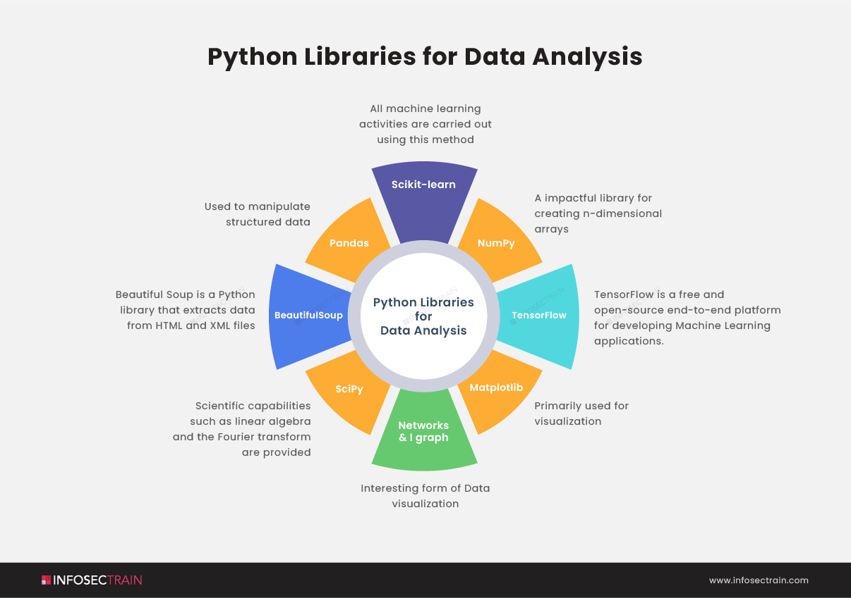

**Figure 2.1.1** Python Libraries

**CHAPTER 3**

**SYSTEM ANALYSIS**

In the journey to develop a cutting-edge book recommendation system, system analysis plays a pivotal role in ensuring that the technical solutions align seamlessly with the diverse needs and preferences of readers. This phase encompasses a systematic evaluation of requirements, functionalities, technical feasibility, user interface design, scalability, and maintenance considerations. Let's delve into each aspect to understand how they contribute to the development of an effective and user-centric book recommendation system.

**Requirement Analysis:**

* Understanding Reader Preferences: Conduct a thorough assessment of reader preferences, including genre preferences, reading habits, favorite authors, and topics of interest.
* Data Acquisition: Gather diverse and comprehensive data sources, including book metadata, user ratings, reviews, and browsing history, to build a rich profile of reader preferences.
* Integration with Existing Platforms: Explore integration possibilities with existing book platforms, such as Goodreads or Amazon, to leverage their data and enhance recommendation accuracy.

**Functional Specifications:**

* Personalized Recommendations: Define functionalities for personalized book recommendations based on user profiles, employing techniques like collaborative filtering, content-based filtering, and hybrid approaches.
* Diverse Recommendation Options: Offer functionalities for diverse recommendation options, including similar books, new releases, trending titles, and curated lists based on thematic interests.
* Real-time Updates: Implement functionalities for real-time updates and recommendations, ensuring that users receive relevant suggestions based on their evolving reading preferences.

**Technical Feasibility:**

* Algorithm Selection: Evaluate the technical feasibility of implementing recommendation algorithms, considering factors such as algorithm complexity, computational resources, and scalability.
* Data Processing: Assess the feasibility of processing and analyzing large volumes of book data, including metadata, user interactions, and external sources, to generate accurate recommendations.
* Performance Metrics: Define performance metrics for evaluating recommendation accuracy, such as precision, recall, and diversity, to ensure that the system meets user expectations.

**User Interface Design:**

* Intuitive Interface: Design a user-friendly interface that enables seamless interaction with the recommendation system across multiple devices.
* Interactive Features: Incorporate interactive features such as book previews, personalized book lists, and recommendation feedback mechanisms to enhance user engagement and satisfaction.
* Accessibility Considerations: Ensure that the user interface is accessible to users with diverse needs, including those with visual impairments or motor disabilities, through features like screen reader compatibility and keyboard navigation.

**Scalability and Maintenance:**

* Modular Architecture: Develop a modular system architecture that supports scalability and facilitates future updates and enhancements without disrupting existing functionality.
* Database Management: Implement robust database management practices to handle growing volumes of book data efficiently and ensure smooth system operation.
* Continuous Monitoring: Establish mechanisms for continuous monitoring and maintenance to address technical issues, update recommendation algorithms, and improve system performance over time.

**Resource Optimization:**

* Automated Recommendation Processes: By automating recommendation processes, the book recommendation system optimizes resource utilization within book platforms, enabling efficient handling of user requests and enhancing overall user experience.
* Enhanced User Engagement: By offering personalized recommendations tailored to individual reading preferences, the book recommendation system fosters deeper user engagement and encourages exploration of new literary genres and authors.

**Research and Development:**

* Innovative Algorithm Development: The book recommendation system contributes to ongoing research and development in the field of recommendation systems by exploring innovative algorithms and techniques for improving recommendation accuracy and diversity.
* User Feedback Integration: Incorporate user feedback and preferences into the recommendation process through iterative algorithm refinement, ensuring that recommendations reflect evolving user tastes and preferences.

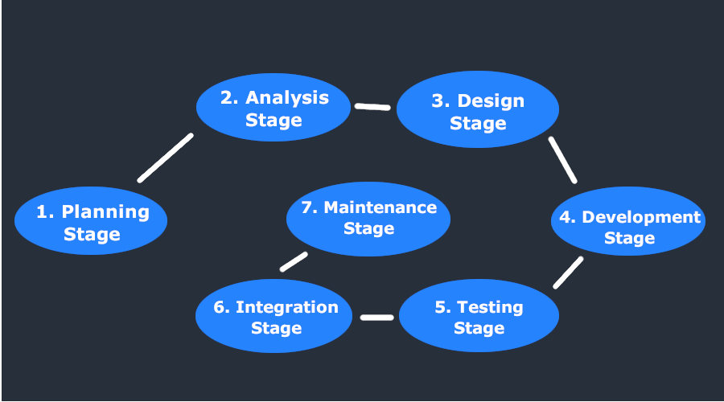

**Figure 3.1.1** System Analysis

Through meticulous system analysis, the personalized book recommendation system aims to deliver a transformative reading experience that empowers readers to discover new literary treasures tailored to their unique interests and preferences.

**CHAPTER 4**

**FEASIBILITY STUDY**

A feasibility study for the development of a Book Recommendation System involves a systematic analysis and evaluation of various factors to assess the practicality, viability, and potential success of the project. The primary purpose of the feasibility study is to determine whether the proposed system is worth investing time, resources, and effort into.

**4.1 Technical Feasibility:**

* Resource Availability: Evaluate the availability of technical resources such as hardware, software, and expertise required for developing and deploying the solution.
* Compatibility Assessment: Assess the compatibility of existing infrastructure with the proposed recommendation algorithms, data processing techniques, and user interface technologies.
* Scalability Evaluation: Determine the scalability of the solution to handle large volumes of book data efficiently, considering factors such as database management, algorithm complexity, and system performance.

**4.2 Financial Feasibility:**

* Cost Estimation: Estimate the costs associated with acquiring hardware, software licenses, datasets, and other resources needed for the project, including development, maintenance, and operational expenses.
* Cost-Benefit Analysis: Conduct a cost-benefit analysis to compare the projected expenses with the expected benefits and potential revenue generation resulting from increased user engagement and book sales.
* Funding Sources: Identify potential sources of funding or investment to support the development and sustainability of the book recommendation system.

**4.3 Operational Feasibility:**

* Workflow Integration: Assess the practicality of integrating the proposed solution into existing book platforms and user workflows.
* User Readiness: Evaluate the readiness of end-users, including readers, authors, and book platform administrators, to adopt and utilize the new recommendation system effectively.
* Operational Challenges: Identify any operational challenges or barriers that may impact the successful implementation and deployment of the solution.

**4.4 Legal and Regulatory Feasibility:**

* Compliance Requirements: Ensure compliance with relevant regulations and standards governing data privacy, intellectual property rights, and consumer protection laws, including GDPR, COPPA, and DMCA.
* Data Handling Policies: Address legal and ethical considerations related to the collection, storage, and sharing of user data, including implementing robust data encryption, user consent mechanisms, and transparent privacy policies.

**4.5 Timeframe and Milestones:**

* Project Timeline: Develop a project timeline outlining key milestones, deliverables, and deadlines for each phase of the project, including requirements gathering, system design, development, testing, and deployment.
* Feasibility Assessment: Assess the feasibility of meeting project deadlines and milestones based on resource availability, technical complexity, and stakeholder collaboration.
* Risk Management: Identify potential risks and mitigation strategies to minimize delays and ensure timely project completion.

By conducting a comprehensive feasibility study, the project team can identify potential challenges, risks, and opportunities early in the project lifecycle, enabling them to make informed decisions and plan effectively for the successful implementation of the Book Recommendation System.

**CHAPTER 5**

**ANALYSIS**

## **5.1 FLOW CHART**

Flow chart is a graphical representation of an algorithm. Programmers often use it as a program-planning tool to solve a problem. It makes use of symbols which are connected among them to indicate the flow of information and processing. The process of drawing a flowchart for an algorithm is known as “flowcharting”.

The flowchart shows the steps as boxes of various kinds, and their order by connecting the boxes with arrows. This diagrammatic representation illustrates a solution model to a given [problem.](https://en.wikipedia.org/wiki/Problem_solving) Flowcharts are used in analyzing, designing, documenting or managing a process or program in various fields

Basic symbols used in flowchart designs:

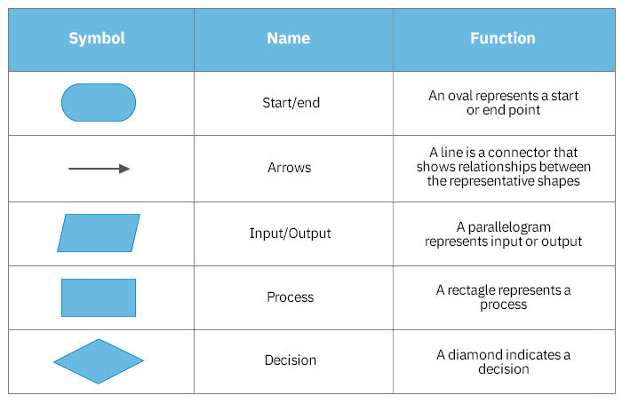

**Table 5.1** flowchart symbols

The graphics above represent different part of a flowchart. The process in a flowchart can be expressed through boxes and arrows with different sizes and colors. In a flowchart, we can easily highlight a certain element and the relationships between each part.

## **5.2 DFD OF BOOK RECOMMENDATION SYSTEM**

**5.2. 1 Book Recommendation System (L1 DFD)**

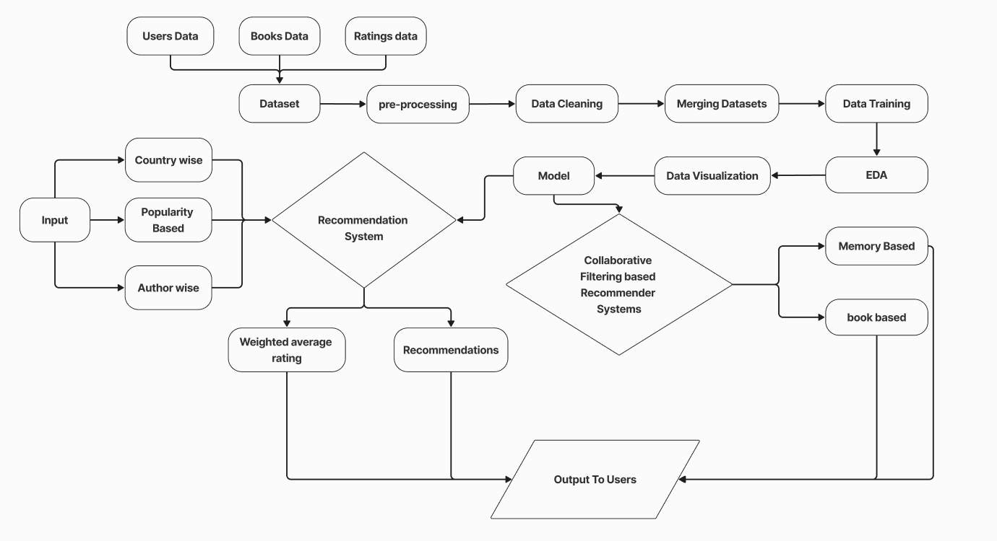

**Figure 5.2. 1** Book Recommendation System (L1 DFD)

### **5.3 MEMORY BASED CF (L2 DFD)**

**5.3. 1 Level 2 DFD**

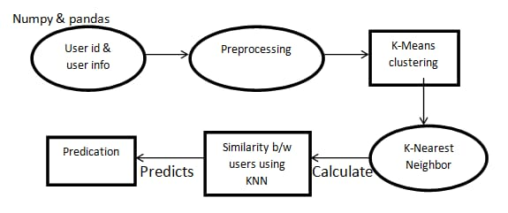

**Figure 5.3. 1** Memory Based CF (L2 DFD)

## **5.4 DFD OF POPULARITY BASED RECOMMENDER SYSTEM**

### **5.4.1 Level 3 DFD**

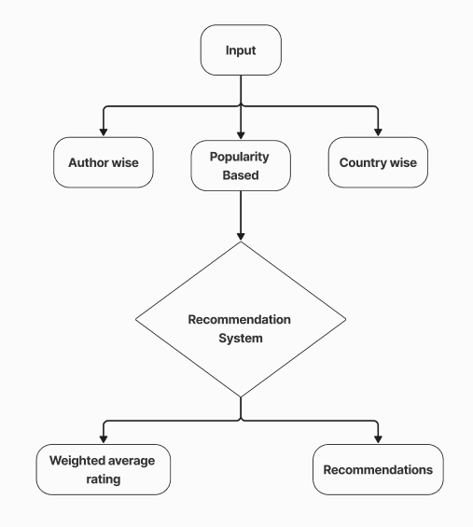

**Figure 5.3. 1** Popularity Based Recommendation System (DFD L1)

**CHAPTER 6**

**S/W ENGINEERING (PARADIGM APPLIED)**

## **6.1 SOFTWARE DEVELOPMENT LIFE CYCLE**

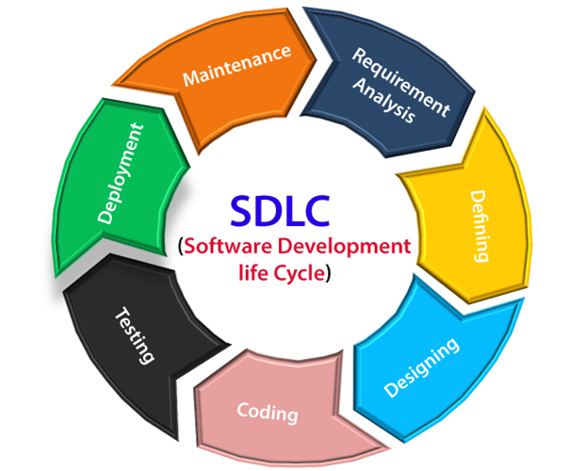SDLC is a process followed for a software project, within a software organization. It consists of a detailed plan describing how to develop, maintain, replace and alter or enhance specific software. The life cycle defines a methodology for improving the quality of software and the overall development process.

**Figure 6.1.1** SDLC

### **6.1.1 Different stages of SDLC**

**1. Requirement Analysis:**

The SDLC process for a book recommendation system begins with thorough Requirement Analysis. Stakeholders, including system users, administrators, and managers, discuss and document the specific requirements of the recommendation system. This phase aims to understand user preferences, types of books, desired features (such as personalized recommendations, genre-based suggestions, etc.), and any constraints the system might have.

**2. Design:**

In the Design phase, technical architects and developers create a high-level design of the recommendation system. This involves determining the system's architecture, data models, algorithms for recommendation generation, and integration points with external systems (such as databases or APIs for accessing book information). The design is documented in detail, including the algorithms used for recommendation generation and any data structures necessary for efficient processing.

**3. Implementation:**

Following the design phase, developers proceed to implement the recommendation system based on the requirements and design specifications. This involves writing code to handle user inputs, process data, and generate personalized recommendations. Backend developers work on algorithms for recommendation generation, while database administrators set up and manage the database infrastructure required to store user preferences and book data. The implementation phase also includes writing unit tests to ensure the functionality of individual components.

**4. Testing:**

Once the implementation phase is complete, the recommendation system undergoes rigorous testing to ensure its functionality, reliability, and performance. Testers create test cases to validate the system against various scenarios, including different user profiles, types of books, and edge cases. Testing also includes evaluating the accuracy and relevance of recommendations generated by the system. Any defects or issues identified during testing are reported to the development team for resolution.

**5. Deployment and Maintenance:**

After successful testing, the recommendation system is deployed to the production environment, where users can start using it to discover books tailored to their preferences. A maintenance team monitors the system in the production environment, addressing any issues or bugs that arise post-deployment. Additionally, the recommendation system is periodically updated to incorporate new features, improve recommendation algorithms, or address changing user needs.

## **6.2 SDLC MODEL TO BE USED (WATERFALL MODEL)**

Waterfall approach was first SDLC Model to be used widely in Software Engineering to ensure success of the project. In "The Waterfall" approach, the whole process of software development is divided into separate phases. In this Waterfall model, typically, the outcome of one phase acts as the input for the next phase sequentially. The following illustration is a representation of the different phases of the Waterfall Model.

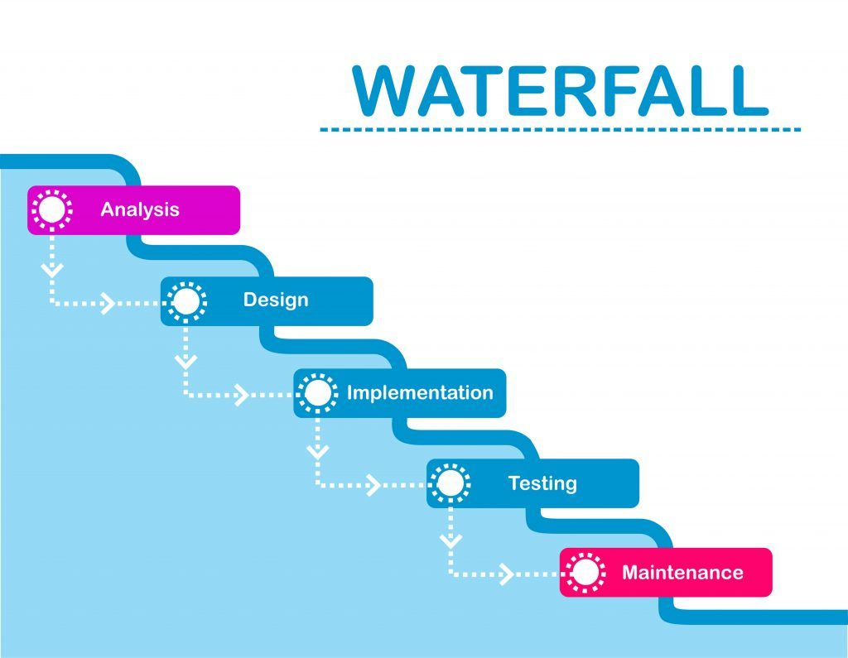

**Figure 6.2.1** Waterfall Model

### **6.2.1 Sequential phases in Waterfall model**

* **Requirement Gathering and analysis** − All possible requirements of the system to be developed are captured in this phase and documented in a requirement specification document.
* **System Design** − The requirement specifications from first phase are studied in this phase and the system design is prepared. This system design helps in specifying hardware and system requirements and helps in defining the overall system architecture.
* **Implementation** − With inputs from the system design, the system is first developed in small programs called units, which are integrated in the next phase. Each unit is developed and tested for its functionality, which is referred to as Unit Testing.
* **Integration and Testing** − All the units developed in the implementation phase are integrated into a system after testing of each unit. Post integration the entire system is tested for any faults and failures.
* **Deployment of system** − Once the functional and non-functional testing is done; the product is deployed in the customer environment or released into the market.
* **Maintenance** − There are some issues which come up in the client environment. To fix those issues, patches are released. Also to enhance the product some better versions are released. Maintenance is done to deliver these changes in the customer environment.

All these phases are cascaded to each other in which progress is seen as flowing steadily downwards (like a waterfall) through the phases. The next phase is started only after the defined set of goals are achieved for previous phase and it is signed off, so the name "Waterfall Model". In this model, phases do not overlap.

### **6.2.2 Waterfall model-applications**

Every software developed is different and requires a suitable SDLC approach to be followed based on the internal and external factors. Some situations where the use of Waterfall model is most appropriate are −

* + Requirements are very well documented, clear and fixed.
  + Product definition is stable.
  + Technology is understood and is not dynamic.
  + There are no ambiguous requirements.
  + Ample resources with required expertise are available to support the product.
  + The project is short.

**CHAPTER 7**

**SYSTEM DESIGN**

The system design of the Bookworm Insight project encompasses the architecture, components, and functionality of the book recommendation system. This chapter provides an in-depth exploration of the design considerations, data flow, and implementation details of the recommendation system, focusing on key aspects such as data collection, preprocessing, algorithm selection, and model deployment.

**7.1 SYSTEM ARCHITECTURE**

The system architecture of the Bookworm Insight project is designed to be modular, scalable, and adaptable to different data sources and recommendation algorithms. At its core, the system consists of the following key components:

**1. Data Collection Module:** Responsible for gathering diverse datasets containing user reading behavior, book metadata, and contextual information from various sources such as online bookstores, libraries, and user interactions.

**2. Data Preprocessing Module:** Cleans and preprocesses the collected data to ensure consistency, quality, and compatibility with the recommendation algorithms. This module handles tasks such as data normalization, feature extraction, and outlier detection.

**3. Recommendation Engine:** The heart of the system, this component employs machine learning algorithms, including collaborative filtering, content-based filtering, and hybrid approaches, to generate personalized book recommendations based on user preferences, book characteristics, and contextual information.

**4. User Interface:** Provides a user-friendly interface for interacting with the recommendation system, allowing users to input their preferences, explore recommended books, and provide feedback to improve recommendation accuracy.

**5. Database Management System:** Stores and manages the collected data, recommendation models, user profiles, and feedback to support efficient data retrieval, storage, and retrieval.

**7.2 DATA FLOW**

The data flow within the Bookworm Insight system follows a structured pipeline, encompassing several stages from data collection to recommendation generation:

**1. Data Collection:** Diverse datasets containing user reading behavior, book metadata, and contextual information are gathered from sources such as online bookstores, libraries, and user interactions.

**2. Data Preprocessing:** The collected data undergoes cleaning and preprocessing to ensure consistency, quality, and compatibility with the recommendation algorithms. This includes tasks such as data normalization, feature extraction, and outlier detection.

**3. Feature Engineering:** Relevant features are extracted from the preprocessed data, including user preferences, book characteristics, and contextual information such as genre, author, publication date, and user demographics.

**4. Model Training:** Machine learning algorithms, including collaborative filtering, content-based filtering, and hybrid approaches, are trained on the preprocessed data to generate personalized book recommendations.

**5. Recommendation Generation:** Based on user input and preferences, the recommendation engine generates personalized book recommendations using the trained machine learning models. These recommendations are then presented to the user through the user interface.

**6. Feedback Collection:** Users have the option to provide feedback on the recommended books, including ratings, reviews, and preferences. This feedback is collected and used to improve the recommendation accuracy and relevance over time.

**7.3 IMPLEMENTATION DETAILS**

The implementation of the Bookworm Insight system involves the selection and integration of various technologies, frameworks, and libraries to support data collection, preprocessing, recommendation generation, and user interaction. Key implementation details include:

**1. Programming Language:** Python is chosen as the primary programming language for its versatility, ease of use, and extensive support for machine learning libraries such as scikit-learn, TensorFlow, and PyTorch.

**2. Database Management System:** A relational database management system (e.g.,CSV) is employed to store and manage the collected data, user profiles, recommendation models, and feedback.

**3. Machine Learning Libraries:** Machine learning algorithms are implemented using popular Python libraries such as scikit-learn, TensorFlow, and PyTorch, which offer a wide range of algorithms and tools for model training, evaluation, and deployment.

**4. User Interface:** The user interface is developed using web technologies such as HTML, CSS, and JavaScript, with frameworks such as React.js or Angular.js to provide a responsive and interactive user experience.

**7.4 SYSTEM SCALABILITY AND PERFORMANCE**

Scalability and performance are critical considerations in the design of the Bookworm Insight system to ensure that it can handle large volumes of data and user interactions efficiently. Strategies for scalability and performance optimization include:

**1. Distributed Computing:** Utilizing distributed computing frameworks such as Apache Spark or Hadoop to distribute data processing tasks across multiple nodes and improve processing speed and efficiency.

**2. Caching and Optimization:** Implementing caching mechanisms to store frequently accessed data and reduce latency in data retrieval. Additionally, optimizing algorithms and data structures to minimize computational overhead and improve recommendation generation speed.

**3. Cloud Deployment:** Leveraging cloud computing platforms such as AWS, Azure, or Google Cloud to dynamically scale resources based on demand, ensuring optimal performance and availability during peak usage periods.

**4. Monitoring and Optimization:** Continuous monitoring of system performance metrics such as response time, throughput, and resource utilization, coupled with proactive optimization strategies to identify and address performance bottlenecks.

**7.5 SECURITY AND PRIVACY CONSIDERATIONS**

Security and privacy are paramount concerns in the design of the Bookworm Insight system, particularly regarding the handling of user data, personal information, and user interactions. Key security and privacy considerations include:

**1. Data Encryption:** Encrypting sensitive data such as user profiles, authentication credentials, and communication channels to protect against unauthorized access and data breaches.

**2. Access Control:** Implementing robust access control mechanisms to restrict access to sensitive data and system functionalities based on user roles and permissions.

**3. Anonymization and De-identification:** Anonymizing and de-identifying user data to remove personally identifiable information (PII) and protect user privacy while still enabling effective recommendation generation.

**4. Compliance with Regulations:** Ensuring compliance with relevant data protection regulations such as GDPR, HIPAA, and CCPA by implementing appropriate security measures, data handling practices, and user consent mechanisms.

# **CHAPTER 8**

# **SCREENSHOTS**

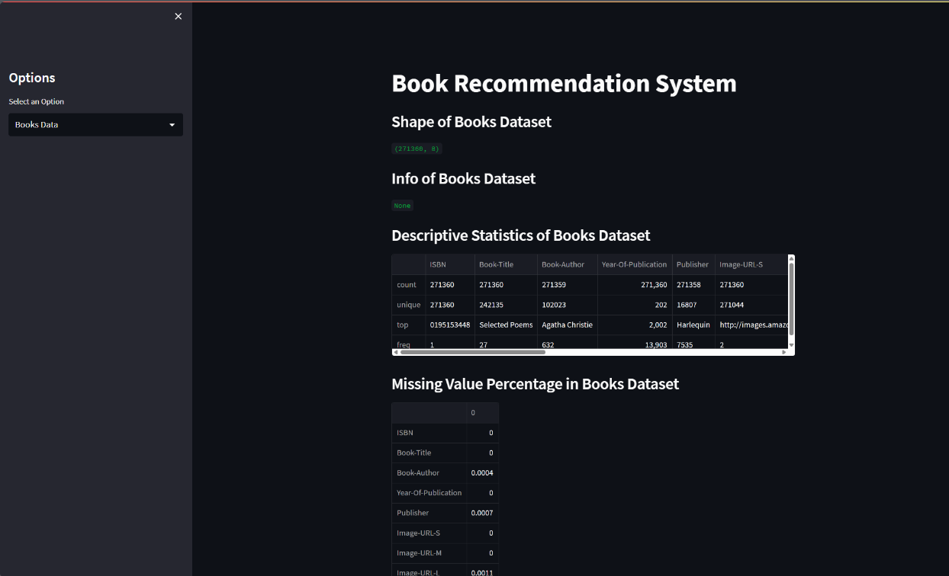

**Figure 8.1** Introductory page

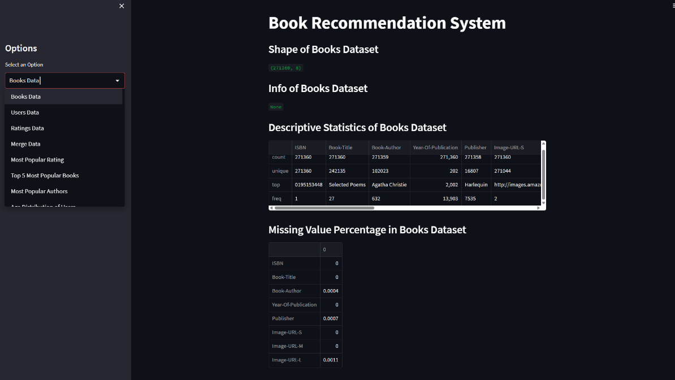

**Figure 8.2** Home page options

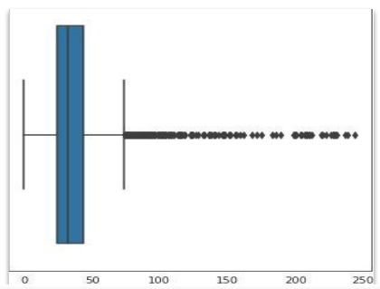

**Figure 8.3** Removing null values from users data

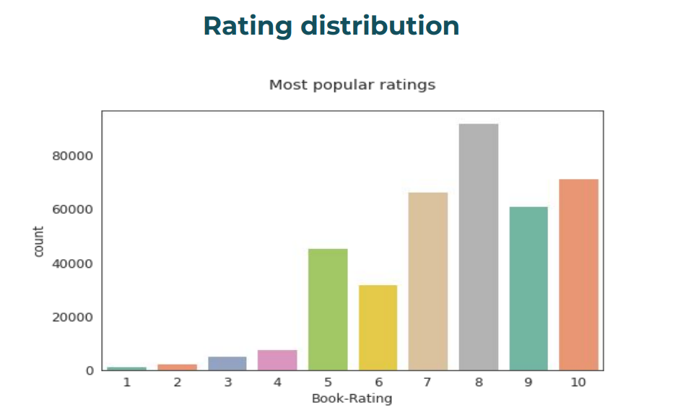

**Figure 8.4** Rating distribution

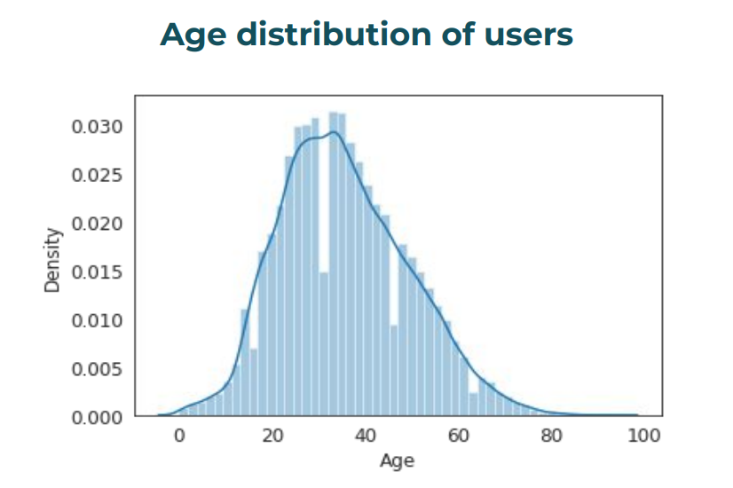

**Figure 8.5** Age distribution of users

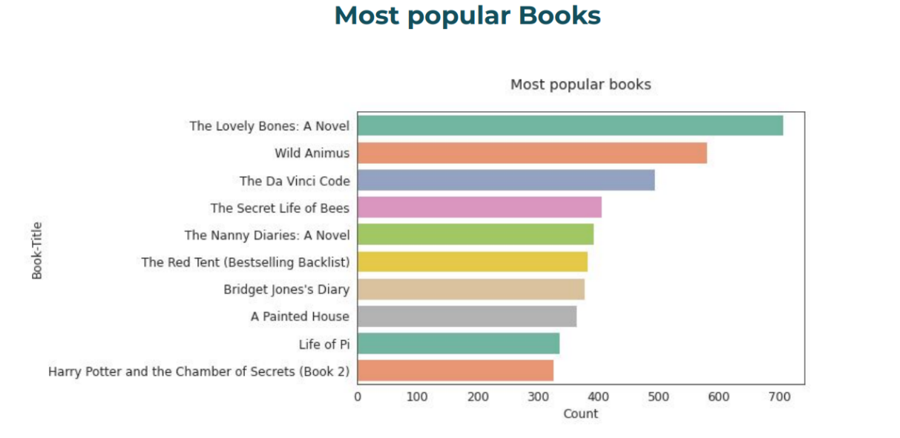

**Figure 8.6** Most popular books

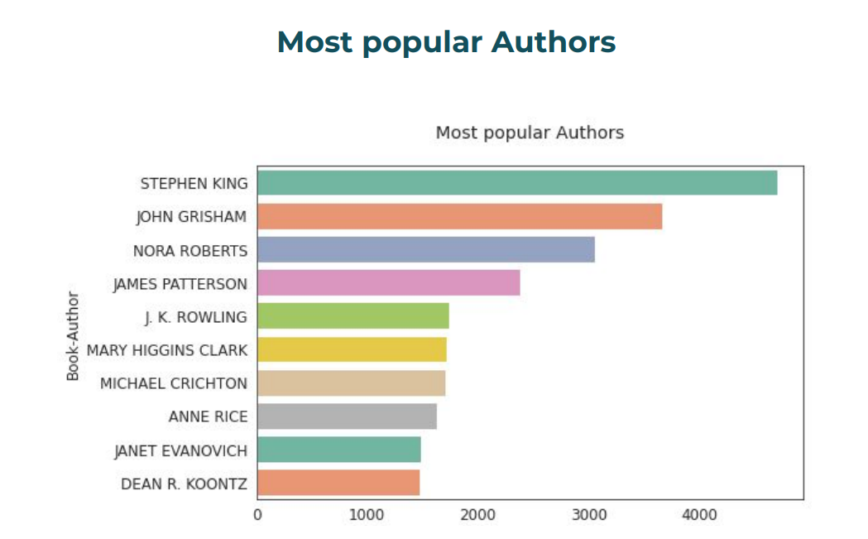

**Figure 8.7** Most popular Authors

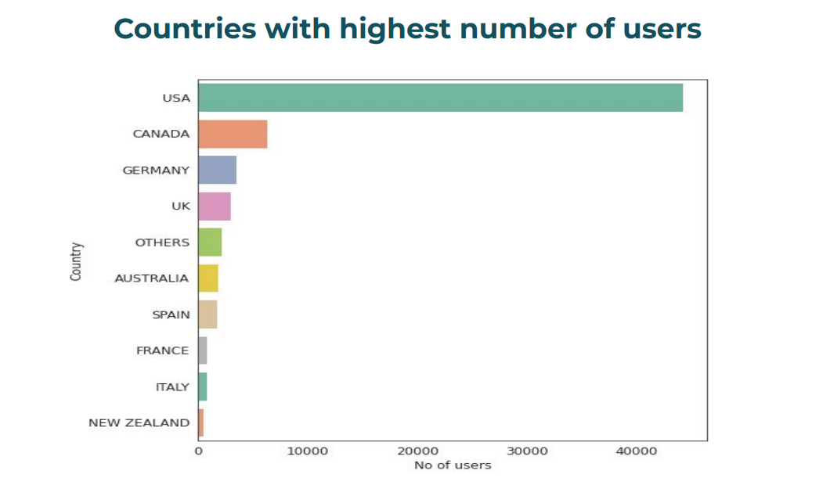

**Figure 8.8** Countries with highest number of users

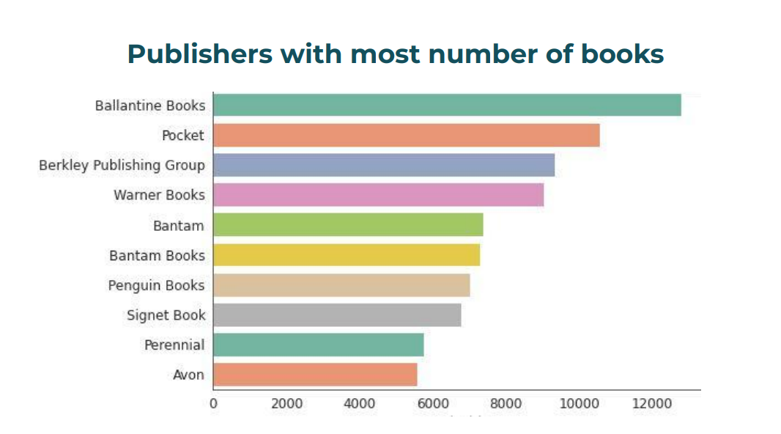

**Figure 8.9** Publishers with most number of books

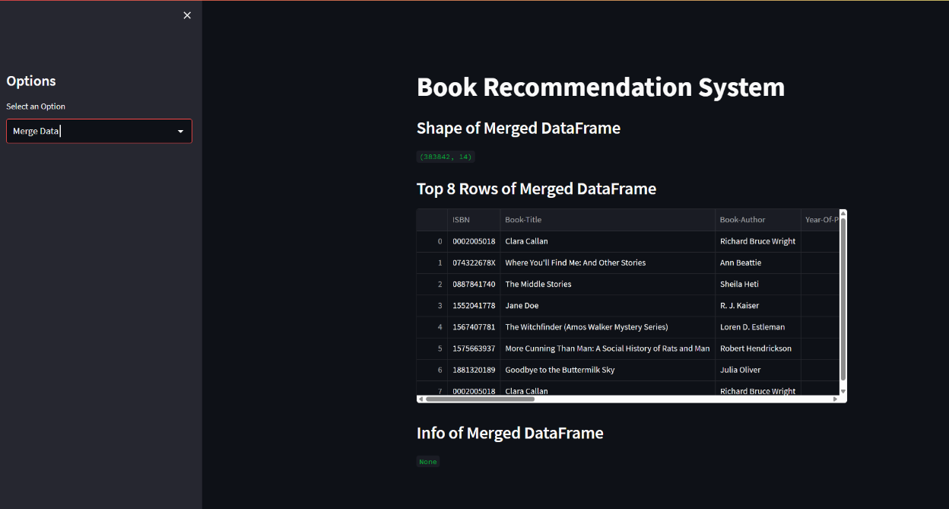

**Figure 8.10** Merged data



**Figure 8.11** Popular book recommendations



**Figure 8.12** Country based recommendation

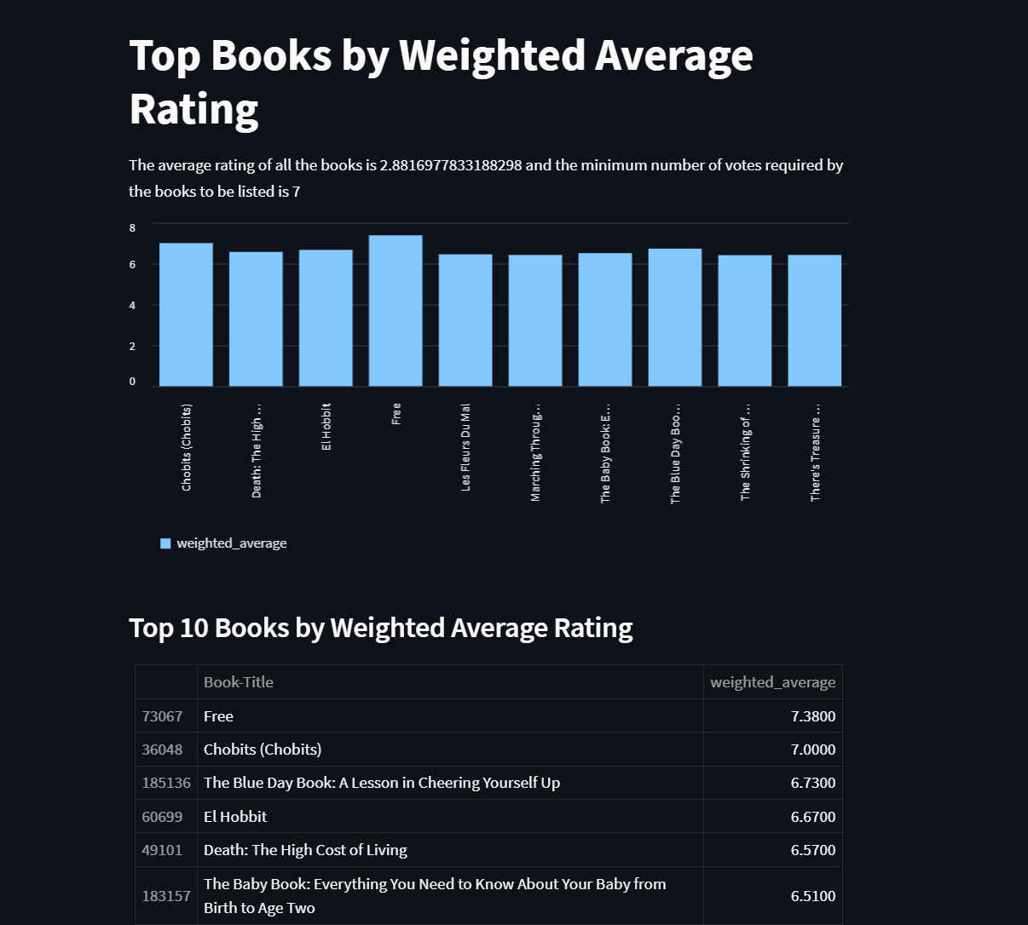

**Figure 8.13** Weighted average rating

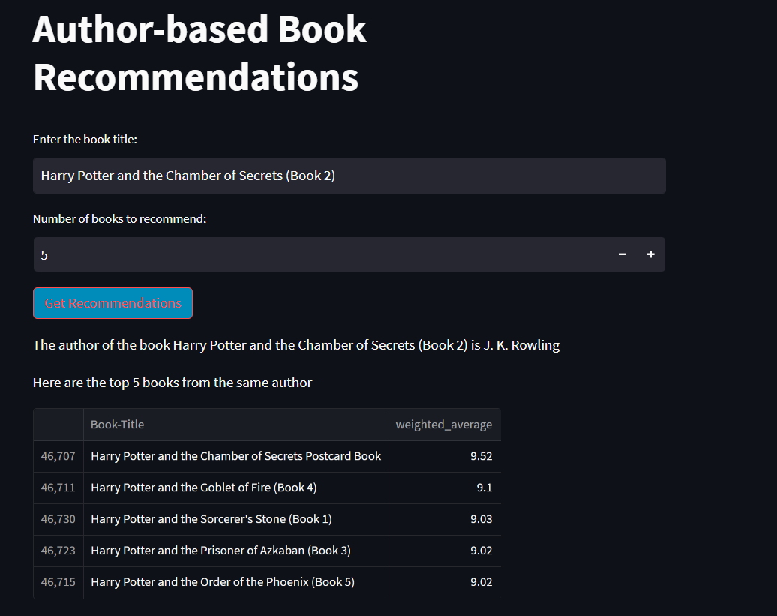

**Figure 8.14** Author based book recommendations

# **CHAPTER 9**

# **MODULES OF THE PROJECT**

## **9.1 HOME PAGE**

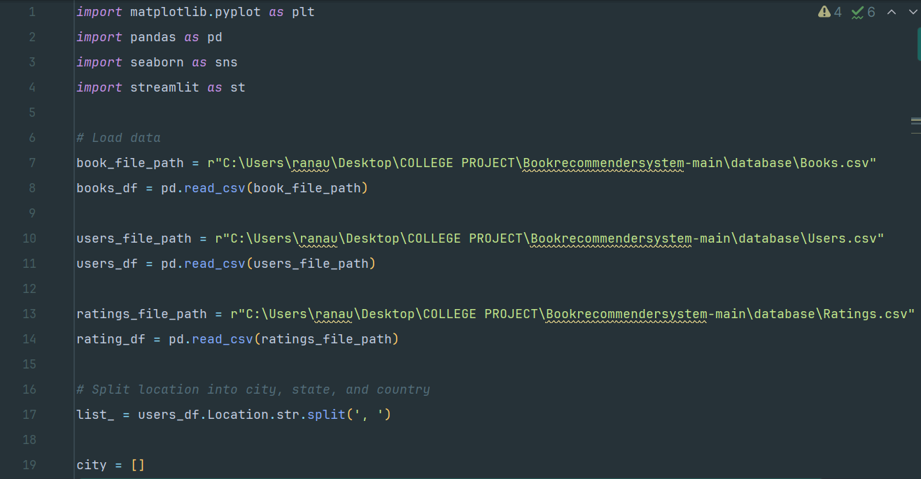

**Figure 9.1** home Page

**9.2 POPULAR BOOK RECOMMENDATIONS**

## 

**Figure 9.2** Popular book recommendations

**9.3 COUNTRY BASED RECOMMENDATION**

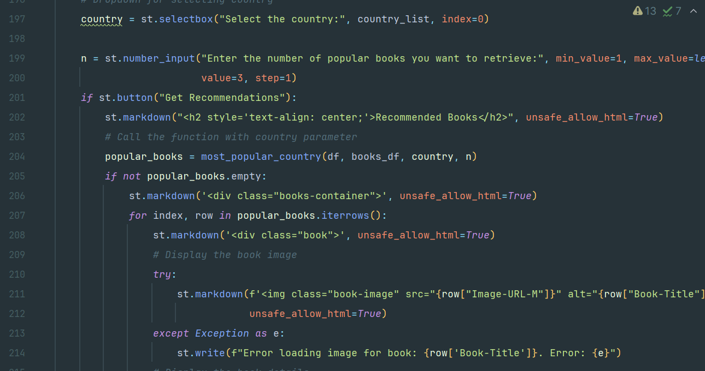

**Figure 9.3** Country based recommendation

**9.4 AUTHOR BASED BOOK RECOMMENDATIONS**

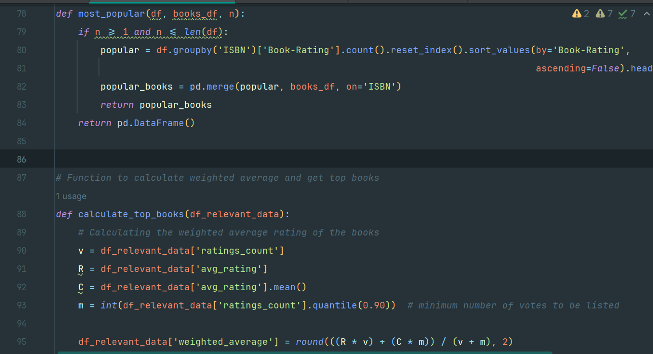

**Figure 9.4** Author based book recommendations

# **CHAPTER 10**

# **VALIDATION CHECKS**

Validation checks are integral to ensuring the effectiveness, reliability, and accuracy of the Bookworm Insight book recommendation system. Here are some validation checks that should be included in the validation process:

**1. Data Quality Validation:**

* Validate the quality and integrity of the book-related data collected from various sources, ensuring accuracy, completeness, and consistency.
* Perform data preprocessing checks to verify the correctness of data normalization, feature extraction, and outlier detection processes.

**2. Model Validation:**

* Validate the machine learning models and recommendation algorithms used in the system.
* Assess the performance of the models using appropriate evaluation metrics such as accuracy, precision, recall, F1 score, and mean average precision (MAP).
* Conduct cross-validation to evaluate the generalization capability of the models and prevent overfitting.

**3. Validation Testing:**

* Conduct validation testing to verify that the recommendation system meets the specified requirements and functionality.
* Perform functional testing to validate core features such as recommendation generation, user interaction, and feedback collection.
* Execute performance testing to evaluate system response time, throughput, and scalability under varying loads.

**4. User Acceptance Testing (UAT):**

* Involve end-users, such as book enthusiasts and readers, in the validation process through UAT.
* Gather feedback from users regarding the relevance, accuracy, and usefulness of the recommended books.
* Incorporate user feedback to improve the recommendation algorithms and enhance the user experience.

**5. Regulatory Compliance Validation:**

* Ensure compliance with relevant regulations and guidelines related to data privacy and consumer protection.
* Validate adherence to regulations such as the General Data Protection Regulation (GDPR) for handling user data and personal information.

**6. Validation Documentation:**

* Document the validation procedures, test cases, and results to maintain a comprehensive record of the validation process.
* Prepare validation reports summarizing the validation activities, outcomes, and any identified issues or deviations.
* Utilize validation documentation to demonstrate the reliability, accuracy, and effectiveness of the Bookworm Insight system to stakeholders and users.

By incorporating these validation checks into the validation process, the Bookworm Insight team can ensure the quality, reliability, and effectiveness of the recommendation system, leading to improved user satisfaction and engagement.

# **CHAPTER 11**

# **TESTING**

Testing plays a crucial role in ensuring the functionality, reliability, and performance of the Bookworm Insight book recommendation system. This chapter outlines various testing

**1. Unit Testing :**

* Conduct unit tests to validate individual components and functions of the recommendation system.
* Test each module, algorithm, and utility function in isolation to ensure correctness and reliability.
* Use testing frameworks such as pytest or unittest to automate unit tests and streamline the testing process.

**2. Integration Testing :**

* Perform integration tests to validate the interaction and integration of different modules and components within the Anaconda environment.
* Test the flow of data and communication between components to identify any integration issues or compatibility issues.
* Verify that the system functions as expected when all components are integrated and working together.

**3. System Testing :**

* Conduct system tests using Jupyter Notebook to evaluate the overall functionality and performance of the recommendation system.
* Test end-to-end scenarios, including user interactions, recommendation generation, and feedback collection.
* Validate system behavior under various conditions, such as different user profiles, preferences, and input data.

**4. Regression Testing :**

* Perform regression tests to ensure that recent code changes or updates do not introduce new bugs or regressions into the system.
* Re-run existing test cases and compare the results against previous test runs to identify any discrepancies or unexpected behavior.

**5. User Acceptance Testing (UAT) :**

* Involve end-users in the testing process through user acceptance testing (UAT) conducted within Jupyter Notebook.
* Gather feedback from users regarding the relevance, accuracy, and quality of the recommended books generated by the system.
* Incorporate user feedback to iteratively improve the recommendation algorithms and enhance the user experience directly within the Jupyter Notebook environment.

**6. Performance Testing with Python Libraries:**

* Conduct performance tests to evaluate the responsiveness, scalability, and throughput of the recommendation system.
* Measure system response times under various load conditions and user concurrency levels to identify performance bottlenecks and optimize system resources.

**7. Security Testing with Anaconda and Python Libraries:**

* Perform security tests using Anaconda and Python libraries to identify and address potential vulnerabilities and security threats in the recommendation system.
* Test for common security risks such as unauthorized access to sensitive data using security testing frameworks and tools available in the Python ecosystem.
* Implement security measures and best practices to mitigate risks and protect user data privacy.

**8. Usability Testing :**

* Conduct usability tests within Jupyter Notebook to evaluate the user interface design and user experience of the recommendation system.
* Test user interactions, navigation flows, and interface elements to ensure intuitive usability and user satisfaction.
* Incorporate user feedback gathered during usability testing to refine and improve the system's usability and user interface design within the Jupyter Notebook environment.

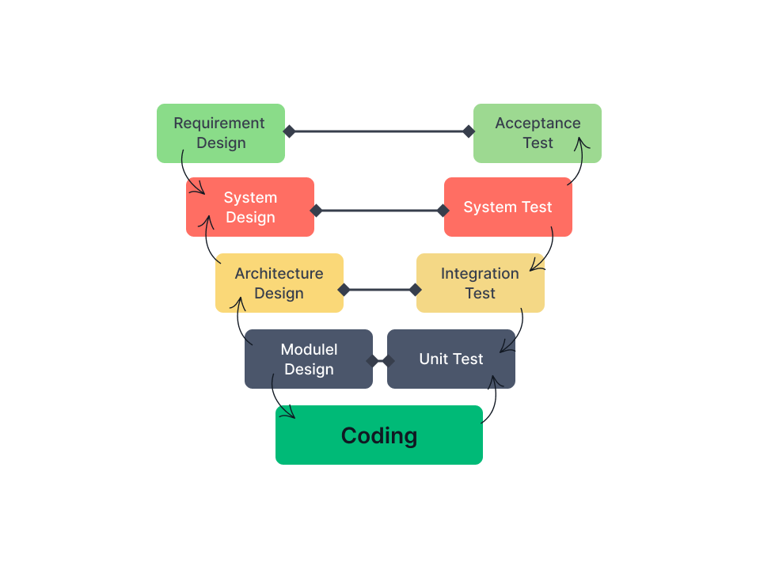

**Figure 11.1** Testings

By employing comprehensive testing methodologies and approaches, the Bookworm Insight team can ensure the reliability, accuracy, and performance of the recommendation system, leading to enhanced user satisfaction and engagement.

# **CHAPTER 12**

# **IMPLEMENTATION OF PROJECT**

In coding and implementation of my project I used various concepts from Python and Flask, the list of the concepts is given as below:

* Random Forest Classifier
* Panda’s data manipulation
* Matplotlib
* Sckit-learn
* Flask
* Convolution Neural Network

**12.1 NUMPY ARRAY MANIPULATION**

NumPy, short for Numerical Python, is a fundamental package for numerical computing in Python. It provides support for arrays, matrices, and mathematical functions to operate on these arrays efficiently. NumPy is widely used in various fields such as machine learning, scientific computing, engineering, and data analysis due to its powerful array manipulation capabilities.

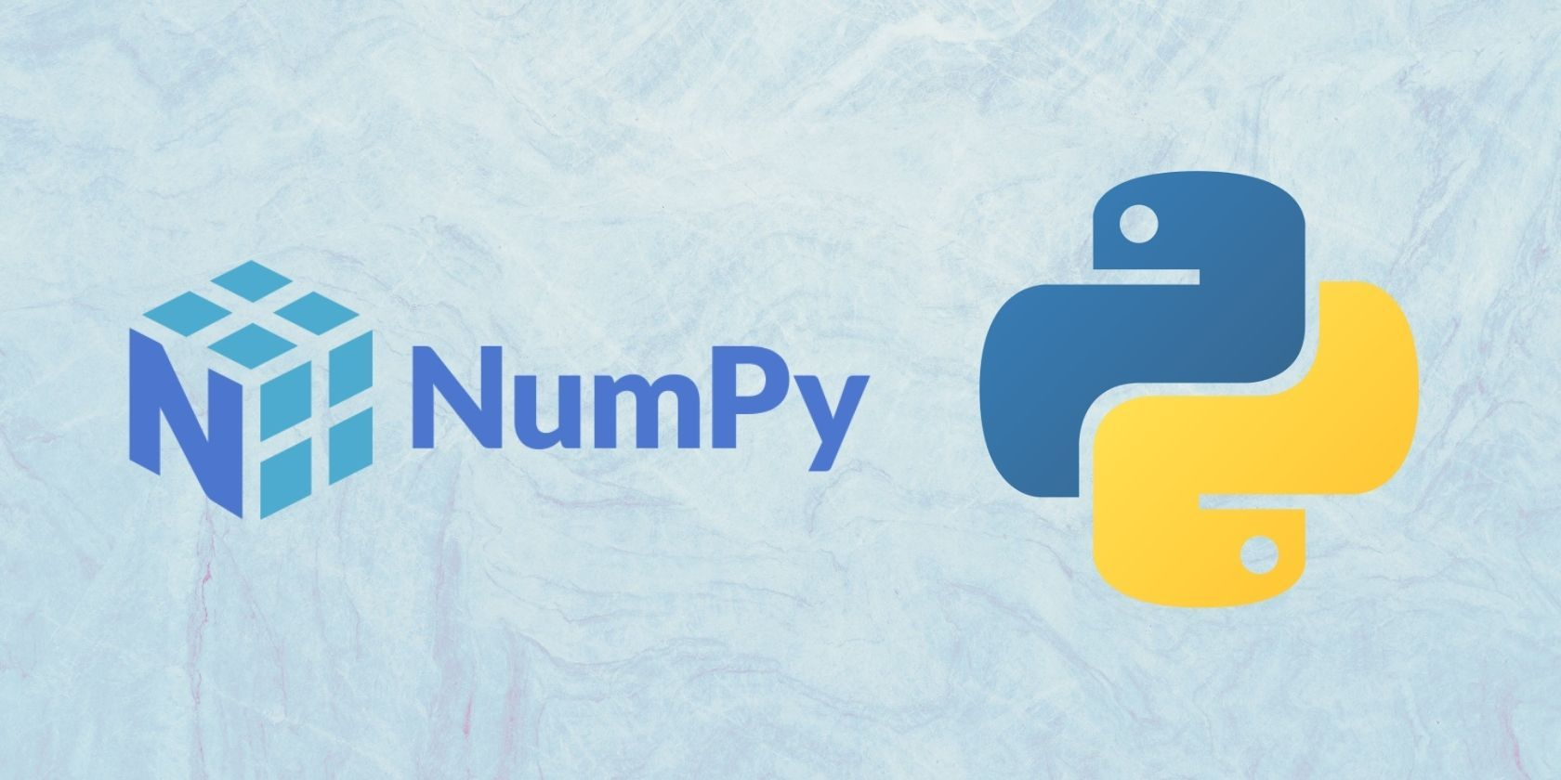

**Figure 12.1.1** Python NumPy

## **12.1.1 What is NumPy used for?**

## NumPy is primarily used for numerical computations and data manipulation tasks. It offers an array object called ndarray, which allows for efficient computation on large datasets. Some common applications of NumPy include:

## Mathematical operations on arrays: NumPy provides a wide range of mathematical functions that operate element-wise on arrays, making it suitable for tasks like linear algebra, Fourier transforms, and random number generation.

## Data manipulation: Similar to Pandas, NumPy facilitates tasks such as data cleaning, merging, and reshaping. It is particularly useful for handling large datasets efficiently.

## Integration with other libraries: NumPy seamlessly integrates with other Python libraries like SciPy (for scientific computing), Matplotlib (for data visualization), and scikit-learn (for machine learning), forming a powerful ecosystem for data analysis and scientific computing.

## **12.1.2 Data structures in NumPy library?**

## NumPy mainly revolves around ndarray, a multidimensional array object that enables fast operations on large datasets. Additionally, it offers other data structures and functions for array manipulation. The primary data structures in NumPy are:

## ndarray: An efficient multidimensional array object that supports mathematical operations and slicing.

## Scalars: NumPy provides various scalar types, including integers, floats, and complex numbers, which are used for individual elements of arrays.

## Arrays: Apart from ndarray, NumPy offers functions to create arrays, such as zeros(), ones(), arange(), linspace(), and random.random(), allowing for easy array initialization and manipulation.

## **1. NumPy ndarray :**

## A NumPy ndarray is a multidimensional array containing elements of the same data type. It is similar to a list in Python but optimized for numerical operations. The key features of ndarray include:

## Homogeneous data: All elements in an ndarray must be of the same data type, which ensures efficient memory usage and computation.

## Shape: An ndarray has a shape attribute that specifies the dimensions of the array, such as the number of rows and columns in a two-dimensional array.

## Indexing and slicing: Similar to lists, ndarrays support indexing and slicing operations to access and manipulate elements efficiently.

Example 1: Creating an ndarray using NumPy library.

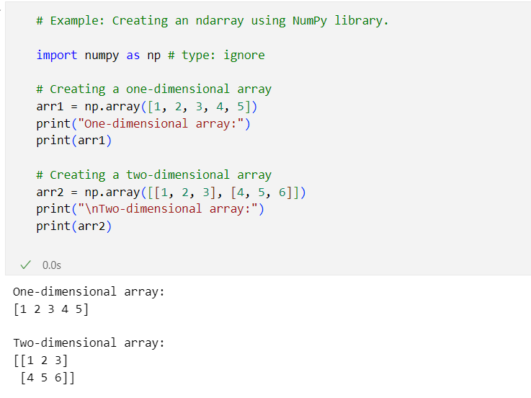

**Figure 12.1.2** Pandas Series Example 1 Program



**Figure 12.1.3** Pandas Series Example 1 Output

## **2. NumPy Scalars**

## Scalars in NumPy represent single values and are often used as elements of arrays. They can have different data types, including integers, floats, and complex numbers. Scalars are essential for mathematical operations and array initialization.

## **3. NumPy Arrays**

## NumPy provides various functions to create arrays efficiently. Some commonly used array creation functions include:

## zeros(): Create an array filled with zeros.

## ones(): Create an array filled with ones.

## arange(): Create an array with a range of values.

## linspace(): Create an array of evenly spaced values.

## random.random(): Create an array of random values.

Example 2: Creating arrays using NumPy library.

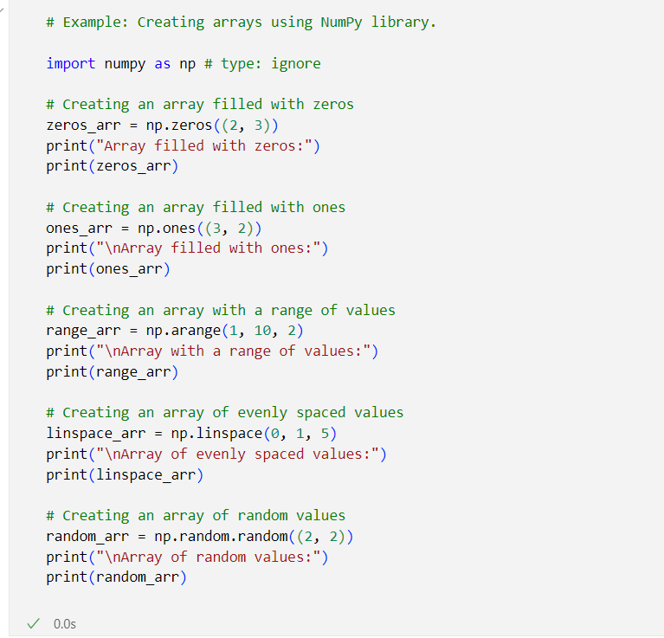

**Figure 12.1.4** Pandas Series Example 2 Program

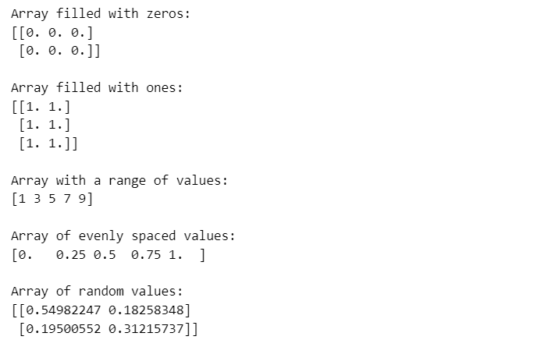

**Figure 12.1.5** Pandas Series Example 2 Output

**How to run NumPy program in Python?**

Similar to Pandas, you can run NumPy programs using any text editor or integrated development environment (IDE) that supports Python. However, using Jupyter Notebook is recommended for its interactive features, which allow you to execute code cells individually and visualize arrays and plots conveniently. Jupyter Notebook provides a seamless environment for data analysis and scientific computing with NumPy.

## **12.2 PANDAS DATA MANIPULATION**

Pandas is a powerful and open-source Python library. The Pandas library is used for data manipulation and analysis. Pandas consist of data structures and functions to perform efficient operations on data.

Pandas is a powerful and versatile library that simplifies the tasks of data manipulation in [Python](https://www.geeksforgeeks.org/python-programming-language/).

Pandas is well-suited for working with tabular data, such as spreadsheets or SQL tables. The Pandas library is an essential tool for data analysts, scientists, and engineers working with structured data in Python. Pandas name is derived from “panel data” and is also referred as “Python Data Analysis “.

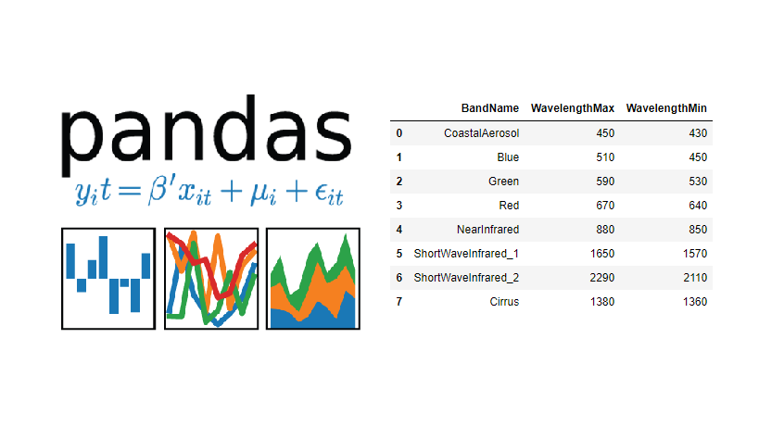

**Figure 12.2.1** Python Pandas

### **12.2.1 What is Pandas used for?**

The Pandas library is generally used for data science, but have you wondered why? This is because the Pandas library is used in conjunction with other libraries that are used for data science. It is built on top of the[NumPy library](https://www.geeksforgeeks.org/python-numpy/) which means that a lot of the structures of NumPy are used or replicated in Pandas. The data produced by Pandas is often used as input for plotting functions in [Matplotlib](https://www.geeksforgeeks.org/python-introduction-matplotlib/), statistical analysis in [SciPy](https://www.geeksforgeeks.org/scipy-linear-algebra-scipy-linalg/), and[machine learning algorithms](https://www.geeksforgeeks.org/machine-learning-algorithms/) in [Scikit-learn](https://www.geeksforgeeks.org/learning-model-building-scikit-learn-python-machine-learning-library/).

You must be wondering, why should you use the Pandas Library. Python’s Pandas library is the best tool to analyze, clean, and manipulate data.

Here is a list of things that we can do using Pandas.

* Data set cleaning, merging, and joining.
* Easy handling of missing data (represented as NaN) in floating point as well as non-floating-point data.
* Columns can be inserted and deleted from DataFrame and higher-dimensional objects.
* Powerful group by functionality for performing split-apply-combine operations on data sets.
* Data Visualization.

### **12.2.2 Data structures in pandas library?**

Pandas generally provide two data structures for manipulating data. They are:

* Series
* DataFrame

1. **Pandas Series**

A [Pandas Series](https://www.geeksforgeeks.org/python-pandas-series/) is a one-dimensional labeled array capable of holding data of any type (integer, string, float, Python objects, etc.). The axis labels are collectively called indexes. The Pandas Series is nothing but a column in an Excel sheet. Labels need not be unique but must be of a hashable type.

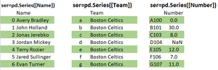

**Figure 12.2.2** Pandas Series Example 1

**Example 2: Creating a series using pandas library.**

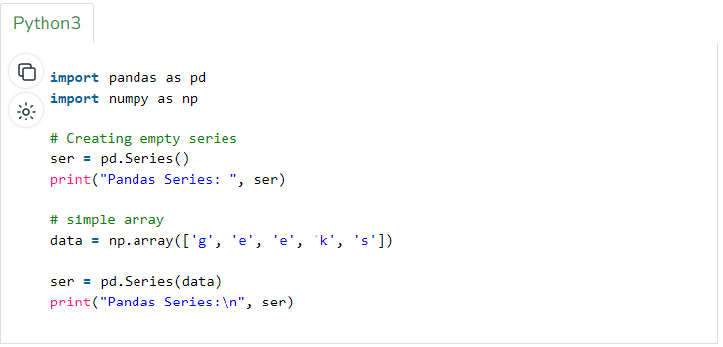

**Figure 12.2.3** Series example 2 program

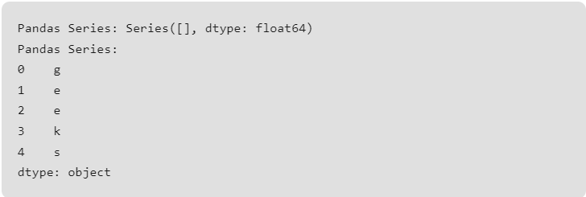

**Figure 12.2.4** Series example 2 output

1. **Pandas DataFrame**

[Pandas DataFrame](https://www.geeksforgeeks.org/python-pandas-dataframe/) is a two-dimensional data structure with labeled axes (rows and columns). Pandas DataFrame is created by loading the datasets from existing storage (which can be a SQL database, a CSV file, or an Excel file).

Pandas DataFrame can be created from lists, dictionaries, a list of dictionaries, etc.

**Example: Creating a DataFrame using pandas library.**

The creation of DataFrame using pandas library is described by the code discussed in the further section of this report

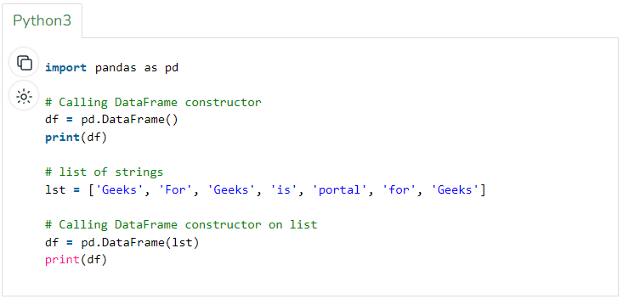

**Figure 12.2.5** DataFrame example 3 program

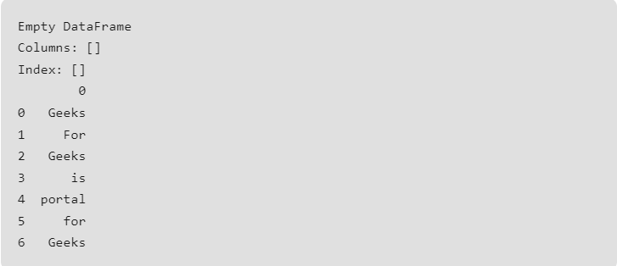

**Figure 12.2.6** DataFrame example 3 output

**How to run pandas program in python?**

The Pandas program can be run from any text editor, but it is recommended to use [Jupyter Notebook](https://www.geeksforgeeks.org/getting-started-with-jupyter-notebook-python/) for this, as Jupyter gives you the ability to execute code in a particular cell rather than the entire file. Jupyter also provides an easy way to visualize Pandas DataFrame and plots.

## **12.3 PYTHON MATPLOTLIB**

Matplotlib is a powerful plotting library in Python used for creating static, animated, and interactive visualizations. Matplotlib’s primary purpose is to provide users with the tools and functionality to represent data graphically, making it easier to analyze and understand. It was originally developed by John D. Hunter in 2003 and is now maintained by a large community of developers.

Human minds are more adaptive for the visual representation of data rather than textual data. We can easily understand things when they are visualized. It is better to represent the data through the graph where we can analyze the data more efficiently and make the specific decision according to data analysis. Before learning the matplotlib, we need to understand data visualization. 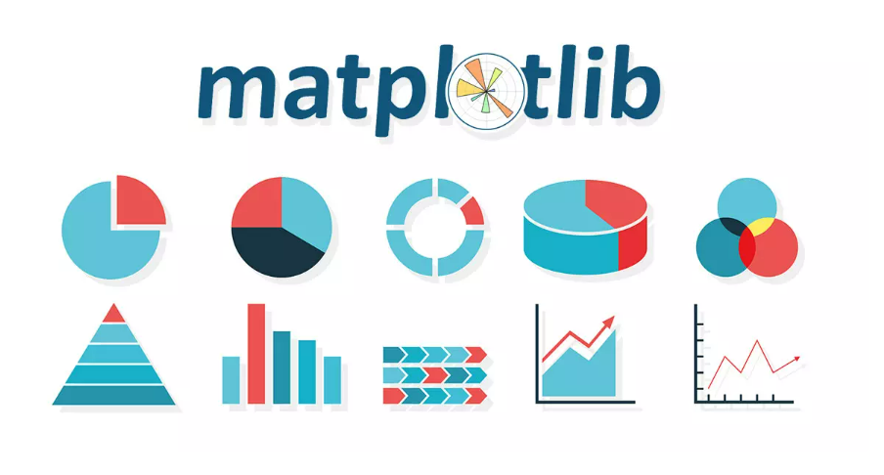

**Figure 12.3.1** Python Matplotlib

**Data Visualization?**

Graphics provides an excellent approach for exploring the data, which is essential for presenting results. Data visualization is a new term. It expresses the idea that involves more than just representing data in the graphical form (instead of using textual form).

This can be very helpful when discovering and getting to know a dataset and can help with classifying patterns, corrupt data, outliers, and much more. With a little domain knowledge, data visualizations can be used to express and demonstrate key relationships in plots and charts. The static does indeed focus on quantitative description and estimations of data. It provides an important set of tools for gaining a qualitative understanding.

There are five key plots that are used for data visualization.

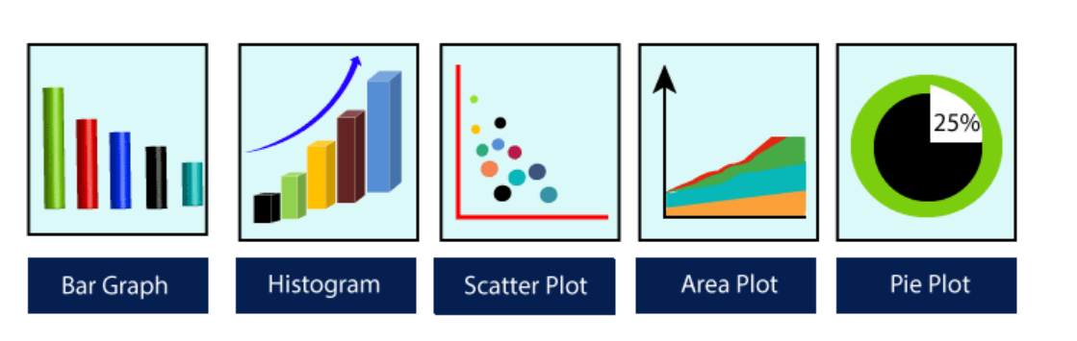

**Figure 12.3.2** data visualization five key plots

### **12.3.1 Key features of Matplotlib:**

The key features of matplotlib are described as below:

* **Versatility:** Matplotlib can generate a wide range of plots, including line plots, scatter plots, bar plots, histograms, pie charts, and more.
* **Customization:** It offers extensive customization options to control every aspect of the plot, such as line styles, colors, markers, labels, and annotations.
* **Integration with NumPy:** Matplotlib integrates seamlessly with NumPy, making it easy to plot data arrays directly.
* **Publication Quality**: Matplotlib produces high-quality plots suitable for publication with fine-grained control over the plot aesthetics.
* **Extensible:** Matplotlib is highly extensible, with a large ecosystem of add-on toolkits and extensions like Seaborn, Pandas plotting functions, and Basemap for geographical plotting.
* **Cross-Platform:** It is platform-independent and can run on various operating systems, including Windows, macOS, and Linux.
* **Interactive Plots:** Matplotlib supports interactive plotting through the use of widgets and event handling, enabling users to explore data dynamically.

### **12.3.2 Parts of matplotlib figure**

In Matplotlib, a figure is the top-level container that holds all the elements of a plot. It represents the entire window or page where the plot is drawn.

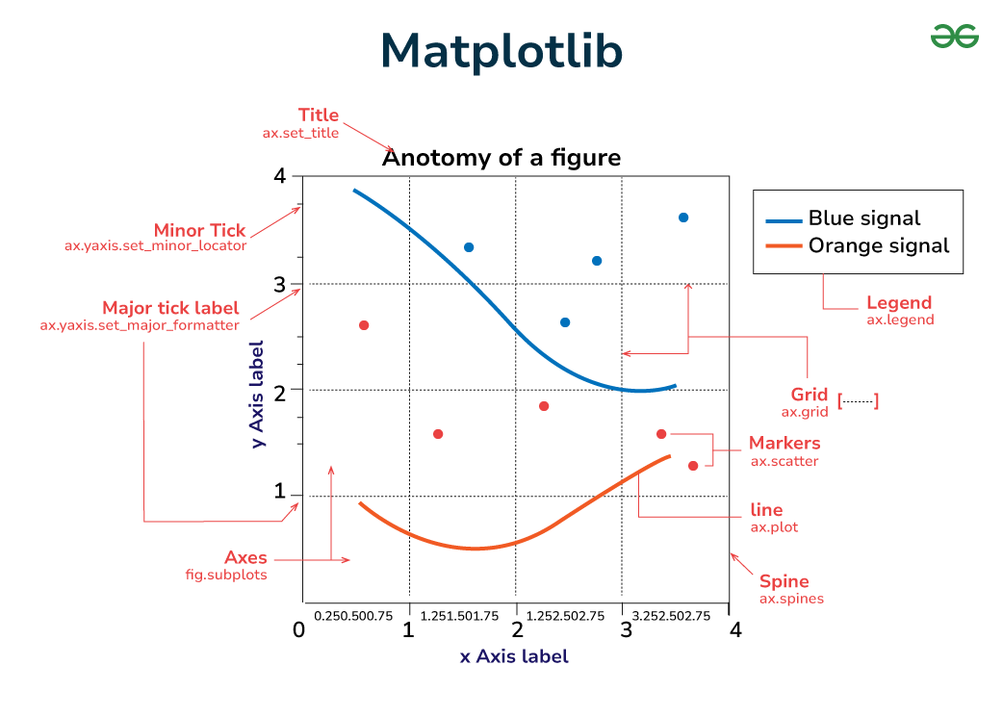

**Figure 12.3.2** Parts of Matplotlib figure

The parts of a Matplotlib figure include (as shown in the figure above):

* **Figures in Matplotlib:** The Figure object is the top-level container for all elements of the plot. It serves as the canvas on which the plot is drawn. You can think of it as the blank sheet of paper on which you’ll create your visualization.
* **Axes in Matplotlib:** Axes are the rectangular areas within the figure where data is plotted. Each figure can contain one or more axes, arranged in rows and columns if necessary. Axes provide the coordinate system and are where most of the plotting occurs.
* **Axis in Matplotlib:** Axis objects represent the x-axis and y-axis of the plot. They define the data limits, tick locations, tick labels, and axis labels. Each axis has a scale and a locator that determine how the tick marks are spaced.
* **Marker in Matplotlib:** Markers are symbols used to denote individual data points on a plot. They can be shapes such as circles, squares, triangles, or custom symbols. Markers are often used in scatter plots to visually distinguish between different data points.
* **Adding lines to Figures:** Lines connect data points on a plot and are commonly used in line plots, scatter plots with connected points, and other types of plots. They represent the relationship or trend between data points and can be styled with different colors, widths, and styles to convey additional information.
* **Matplotlib Title:** The title is a text element that provides a descriptive title for the plot. It typically appears at the top of the figure and provides context or information about the data being visualized.
* **Axis Labels in Matplotlib:** Labels are text elements that provide descriptions for the x-axis and y-axis. They help identify the data being plotted and provide units or other relevant information.
* **Ticks:** Tick marks are small marks along the axis that indicate specific data points or intervals. They help users interpret the scale of the plot and locate specific data values.
* **Tick Labels:** Tick labels are text elements that provide labels for the tick marks. They usually display the data values corresponding to each tick mark and can be customized to show specific formatting or units.
* **Matplotlib Legend:** Legends provide a key to the symbols or colors used in the plot to represent different data series or categories. They help users interpret the plot and understand the meaning of each element.
* **Matplotlib Grid Lines:** Grid lines are horizontal and vertical lines that extend across the plot, corresponding to specific data intervals or divisions. They provide a visual guide to the data and help users identify patterns or trends.
* **Spines of Matplotlib Figures:** Spines are the lines that form the borders of the plot area. They separate the plot from the surrounding whitespace and can be customized to change the appearance of the plot borders.

### **12.3.3 Types of plots in matplotlib**

Matplotlib offers a wide range of plot types to suit various data visualization needs. Here are some of the most commonly used types of plots in Matplotlib:

* Line Graph
* Stem Plot
* Bar chart
* Histograms
* Scatter Plot
* Box Plot
* Pie Chart

### **12.3.4 Advantages of matplotlib**

Matplotlib is a widely used plotting library in Python that provides a variety of plotting tools and capabilities. Here are some of the advantages of using Matplotlib:

* **Versatility:** Matplotlib can create a wide range of plots, including line plots, scatter plots, bar plots, histograms, pie charts, and more.
* **Customization:** It offers extensive customization options to control every aspect of the plot, such as line styles, colors, markers, labels, and annotations.
* **Integration with NumPy:** Matplotlib integrates seamlessly with NumPy, making it easy to plot data arrays directly.
* **Publication Quality:** Matplotlib produces high-quality plots suitable for publication with fine-grained control over the plot aesthetics.
* **Wide Adoption:** Due to its maturity and flexibility, Matplotlib is widely adopted in the scientific and engineering communities.
* **Extensible:** Matplotlib is highly extensible, with a large ecosystem of add-on toolkits and extensions like Seaborn, Pandas plotting functions, and Basemap for geographical plotting.
* **Cross-Platform:** It is platform-independent and can run on various operating systems, including Windows, macOS, and Linux.
* **Interactive Plots:** Matplotlib supports interactive plotting through the use of widgets and event handling, enabling users to explore data dynamically.
* **Integration with Jupyter Notebooks**: Matplotlib works seamlessly with Jupyter Notebooks, allowing for interactive plotting and inline display of plots.
* **Rich Documentation and Community Support:** Matplotlib has comprehensive documentation and a large community of users and developers, making it easy to find help, tutorials, and examples.

### **12.3.5 Disadvantages of matplotlib**

While Matplotlib is a powerful and versatile plotting library, it also has some disadvantages that users might encounter which are being discussed in the further section of this report:

1. **Steep Learning Curve:** For beginners, Matplotlib can have a steep learning curve due to its extensive customization options and sometimes complex syntax.
2. **Verbose Syntax:** Matplotlib’s syntax can be verbose and less intuitive compared to other plotting libraries like Seaborn or Plotly, making it more time-consuming to create and customize plots.
3. **Default Aesthetics:** The default plot aesthetics in Matplotlib are often considered less visually appealing compared to other libraries, requiring more effort to make plots visually attractive.
4. **Limited Interactivity:** While Matplotlib does support interactive plotting to some extent, it does not offer as many interactive features and options as other libraries like Plotly.
5. **Limited 3D Plotting Capabilities**: Matplotlib’s 3D plotting capabilities are not as advanced and user-friendly as some other specialized 3D plotting libraries.
6. **Performance Issues with Large Datasets:** Matplotlib can sometimes be slower and less efficient when plotting large datasets, especially compared to more optimized plotting libraries.
7. **Documentation and Error Messages:** Although Matplotlib has comprehensive documentation, some users find it challenging to navigate, and error messages can sometimes be cryptic and hard to debug.
8. **Dependency on External Libraries:** Matplotlib relies on other libraries like NumPy and SciPy for many of its functionalities, which can sometimes lead to compatibility issues and dependency management issues.
9. **Limited Native Support for Statistical Plotting:** While Matplotlib can create basic statistical plots, it lacks some advanced statistical plotting capabilities that are available in specialized libraries like Seaborn.
10. **Less Modern Features:** Matplotlib has been around for a long time, and some users find that it lacks some of the modern plotting features and interactive visualization capabilities found in newer libraries.

Despite these disadvantages, Matplotlib remains a popular choice for data visualization in Python due to its flexibility, versatility, and extensive capabilities. Many of its limitations can be overcome with practice, and it can be effectively used for creating high-quality plots with the right knowledge and skills. Matplotlib is a versatile and powerful library for creating high-quality plots and visualizations in Python. With its extensive customization options and wide range of plotting capabilities, it is widely used in the scientific, engineering, and data science communities for data exploration, analysis, and presentation.

## **12.4 PYTHON SCKIT-LEARN**

Scikit-learn has emerged as a powerful and user-friendly Python library. Its simplicity and versatility make it a better choice for both beginners and seasoned data scientists to build and implement machine learning models. In this article, we will explore about Sklearn. Scikit-learn is an open-source[Python](https://www.geeksforgeeks.org/python-programming-language/) library that implements a range of machine learning, pre-processing, cross-validation, and visualization algorithms using a unified interface. It is an open-source machine-learning library that provides a plethora of tools for various [machine-learning](https://www.geeksforgeeks.org/machine-learning/) tasks such as[Classification](https://www.geeksforgeeks.org/basic-concept-classification-data-mining/), [Regression](https://www.geeksforgeeks.org/regression-classification-supervised-machine-learning/), [Clustering](https://www.geeksforgeeks.org/clustering-in-machine-learning/), and many more.



**Figure 12.4** Python Sckit-learn

### **12.4.1 Features of Scikit-learn**

* Simple and efficient tools for data mining and data analysis. It features various classification, regression, and clustering algorithms including support vector machines, random forests, gradient boosting, k-means, etc.
* Accessible to everybody and reusable in various contexts.
* Built on the top of NumPy, SciPy, and matplotlib.
* Open source, commercially usable – BSD license.
* Benefits of using Scikit-learn Libraries
* Consistent interface to machine learning models
* Provides many tuning parameters but with sensible defaults.
* Exceptional documentation
* Rich set of functionalities for companion tasks.
* Active community for development and support.

Scikit-learn stands as stone in the field of machine learning, providing a straightforward yet powerful toolset for building and deploying models. Whether you are a beginner explore the basics or an experienced data scientist tackle complex problems.

### **12.4.2 Advantages of Sckit-learn**

* **Simplicity:** Flask is known for its simplicity and minimalism, making it easy to learn and use, especially for beginners.
* **Flexibility:** Flask is highly flexible, allowing developers to choose the components and extensions they need for their specific project requirements.
* **Extensibility:** Flask has a rich ecosystem of extensions that provide additional functionality, such as authentication, database integration, and more.
* **Lightweight:** Flask has a small footprint and minimal dependencies, making it lightweight and fast, which is advantageous for performance-sensitive applications.
* **Built-in Development Server:** Flask comes with a built-in development server, allowing developers to test their applications quickly without needing to set up a separate server environment.
* **RESTful Support:** Flask provides support for building RESTful APIs, making it suitable for developing backend services and microservices.
* **Community and Documentation:** Flask has a large and active community of developers, as well as comprehensive documentation and tutorials, making it easy to find help and resources.

**12.5 PYTHON STREAMLIT**

Streamlit is a powerful Python framework tailored for swiftly developing interactive web applications and dashboards, particularly in the realm of data-driven projects. Its hallmark lies in its simplicity and efficiency, empowering developers to create compelling applications with minimal code. By automatically generating user interfaces from Python scripts, Streamlit streamlines the development process, eliminating the need for manual HTML or CSS coding. Its integration with popular Python libraries such as Pandas and Matplotlib facilitates seamless data manipulation and visualization, while interactive widgets enable users to dynamically engage with the application's content. Moreover, Streamlit's live updating feature ensures that applications reflect real-time changes in data or code, enhancing user experience. Whether for data analysis, machine learning experimentation, or project showcasing, Streamlit offers a versatile platform supported by a thriving community and robust deployment options, making it an invaluable tool for developers and data enthusiasts alike.

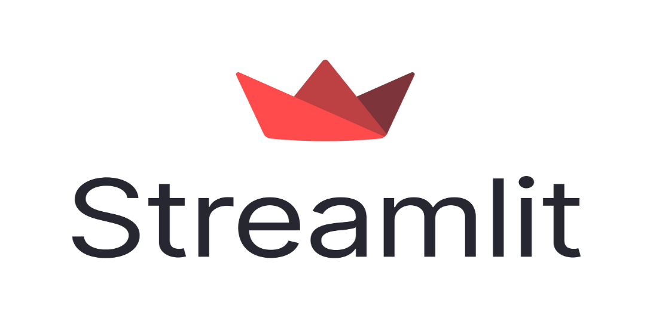

**Figure 12.5** Python Flask

## Streamlit is another popular Python framework, particularly for building data-driven web applications and interactive dashboards. Here's a breakdown of its features:

## **1. Rapid Prototyping**: Streamlit excels in rapid prototyping, allowing developers to quickly build interactive web applications using Python scripts.

## **2. Simplicity:** Similar to Flask, Streamlit emphasizes simplicity and ease of use. Its intuitive API allows developers to create powerful applications with minimal code.

## **3. Automatic UI Generation:** Streamlit automatically generates the user interface based on the Python code, eliminating the need for manual HTML or CSS coding.

## **4. Live Updates:** Applications built with Streamlit automatically update as the underlying data or code changes, providing users with real-time insights.

## **5. Integration with Python Libraries**: Streamlit seamlessly integrates with popular Python libraries for data manipulation, visualization, and machine learning, such as Pandas, Matplotlib, and Scikit-learn.

## Like Flask, Streamlit is well-suited for a wide range of projects, particularly those involving data analysis, visualization, and machine learning. Its simplicity and rapid development capabilities make it a popular choice among data scientists, researchers, and developers seeking to create interactive web applications with minimal effort.

## **12.6** **EXPLORATORY DATA ANALYSIS (EDA)**

## Exploratory Data Analysis (EDA) is a fundamental approach in data science for gaining insights into datasets, understanding their underlying structure, and formulating hypotheses. It involves a variety of techniques to summarize, visualize, and interpret the characteristics of the data.

## 

## **Key Components of EDA:**

## **• Summary Statistics:** EDA often begins with computing summary statistics such as mean, median, standard deviation, and percentiles to describe the central tendency, spread, and distribution of the data.

## **• Data Visualization:** Visualization plays a crucial role in EDA, allowing analysts to explore relationships, patterns, and anomalies within the data. Techniques like histograms, box plots, scatter plots, and heatmaps provide intuitive representations of the data's characteristics.

## **• Data Cleaning:** Before delving into analysis, data cleaning is essential to address missing values, outliers, and inconsistencies in the dataset. EDA typically involves identifying and handling these issues to ensure the integrity and reliability of the analysis.

## **• Feature Engineering:** EDA often informs feature engineering, where new features are derived or transformed from existing ones to improve model performance. This may include creating interaction terms, encoding categorical variables, or scaling numerical features.

## **Advantages of Exploratory Data Analysis:**

## **• Insight Generation:** EDA facilitates the discovery of patterns, trends, and relationships within the data, leading to actionable insights and informed decision-making.

## **• Data Understanding:** By visually exploring the data, analysts gain a deeper understanding of its structure, distribution, and potential biases, enabling them to make better-informed modeling choices.

## **• Hypothesis Formulation:** EDA helps in generating hypotheses about the underlying relationships in the data, which can be further investigated using statistical tests or machine learning models.

## **• Effective Communication:** Visualizations generated during EDA serve as powerful tools for communicating findings to stakeholders, conveying complex information in a clear and interpretable manner.

## **Disadvantages of Exploratory Data Analysis:**

## **• Subjectivity:** EDA relies on the analyst's interpretation of visualizations and summary statistics, which may introduce subjective biases into the analysis.

## **• Time-Consuming:** Performing thorough EDA can be time-consuming, especially for large and complex datasets, as it involves exploring multiple dimensions and variables.

## **• Limited Scope:** While EDA provides valuable insights into the data, it may not uncover all underlying patterns or relationships, requiring complementary analytical techniques for comprehensive understanding.

## In summary, Exploratory Data Analysis serves as a critical initial step in the data analysis process, providing a foundation for subsequent modeling and inference tasks by revealing key insights and informing decision-making.

# **CHAPTER 13**

# **SYSTEM SECURITY MEASURES**

Implementing robust system security measures is crucial for safeguarding sensitive medical data in the ‘Books Recommendation System’ project. This involves measures such as data encryption, access control, authentication mechanisms, and audit trails to ensure data integrity and prevent unauthorized access. Regular security audits, compliance with regulations, and secure software development practices are also essential to mitigate security risks effectively. By prioritizing these measures, ‘Books Recommendation System’ can maintain patient privacy, uphold trust, and mitigate potential security threats effectively.

In the realm of digital systems, security is paramount, particularly in systems dealing with sensitive user data like book recommendation platforms. This chapter delves into the crucial aspects of securing a book recommendation system to ensure the confidentiality, integrity, and availability of user information.

1. **Data Encryption:**

* Implement robust encryption mechanisms to protect sensitive user data, such as personal preferences and reading history.
* Utilize encryption algorithms to secure data at rest within databases and during transmission over networks.

1. **Access Control:**

* Enforce strict access control measures to authenticate and authorize users accessing the recommendation system.
* Implement multi-factor authentication (MFA) to add an extra layer of security during user authentication.

1. **Secure User Authentication:**

# Utilize techniques like password hashing and salting to safeguard user credentials stored in the database.

# **4. Input Validation:**

# Implement thorough input validation mechanisms to sanitize user inputs and prevent injection attacks like SQL injection and cross-site scripting (XSS).

# Validate user inputs at both client and server sides to mitigate security risks associated with malicious inputs.

# **5. Secure API Endpoints:**

# Securely expose API endpoints used by the recommendation system, ensuring proper authentication and authorization mechanisms are in place.

# Utilize token-based authentication to authenticate API requests and enforce access control policies.

# **6. Logging and Monitoring:**

# Implement comprehensivelogging mechanisms to record user activities, system events, and potential security incidents.

# Set up real-time monitoring systems to detect anomalies and suspicious activities, enabling proactive response to security threats.

# **7. Regular Security Audits:**

# Conduct periodic security audits and vulnerability assessments to identify and address potential security loopholes.

# Engage third-party security experts to perform penetration testing and security assessments to uncover hidden vulnerabilities.

# **8. Compliance with Data Protection Regulations:**

# Ensure compliance with relevant data protection regulations, such as GDPR (General Data Protection Regulation) and CCPA (California Consumer Privacy Act).

# Implement necessary measures to safeguard user privacy rights and adhere to data handling requirements mandated by regulations.

# **9. Disaster Recovery and Incident Response:**

# Develop a robust disaster recovery plan to mitigate the impact of security incidents and system failures.

# Establish incident response procedures to quickly detect, respond to, and recover from security breaches or data breaches.

# **10. Continuous Security Improvement:**

# Foster a culture of security awareness within the organization, providing regular training and education to employees on security best practices.

# Continuously assess and improve security measures, staying abreast of emerging threats and evolving security technologies.

# By implementing these system security measures, a book recommendation system can fortify its defenses against potential security threats and safeguard the trust and confidence of its users. Remember, security is not a one-time effort but an ongoing commitment to protecting user data and maintaining the integrity of the system.

# **CHAPTER 14**

**PERT CHART**

**Definition**

A Pert Chart is a graphical representation of project tasks and their interdependencies. It provides a visual roadmap for project managers, team members, and stakeholders, helping them understand the sequence of tasks, task durations, and critical paths.

**Purpose**

The Pert Chart for our online shop application served several essential purposes:

* **Task Sequencing**: It allowed us to determine the order in which tasks needed to be executed to achieve project goals efficiently.
* **Dependency Visualization**: The chart illustrated the dependencies between tasks, helping us identify which tasks were prerequisites for others.
* **Timeline Planning**: We used the Pert Chart to estimate task durations and plan the project timeline, setting clear deadlines for each task.
* **Risk Identification**: By visualizing the critical path, we could identify potential bottlenecks and risks that could impact the project schedule.

**Components of the Pert Chart**

**Task Nodes**

* **Requirements Gathering**: Identifying and documenting project requirements.
* **System Design**: Defining the system architecture, database design, and user interface.
* **Development**: Writing code for the frontend and backend .
* **Testing**: Conducting unit tests, integration tests, and user acceptance testing (UAT).
* **Deployment**: Launching the application to staging and production environments.
* **Maintenance**: Ongoing bug fixes, updates, and performance optimization.

|  |  |  |  |
| --- | --- | --- | --- |
| Task | Starting date | Ending date | Duration (Days) |
| Planning | Feb 1, 2024 | Feb 10, 2024 | 10 |
| home Page module | Feb 11, 2024 | March 10, 2024 | 29 |
| Popular book recommendations module | March 11, 2024 | March 27, 2024 | 17 |
| Country based recommendation module | March 28, 2024 | April 15, 2024 | 19 |
| Author based book recommendations module | April 16, 2024 | May 3, 2024 | 18 |

**Table 14.1** Timeline of entire project

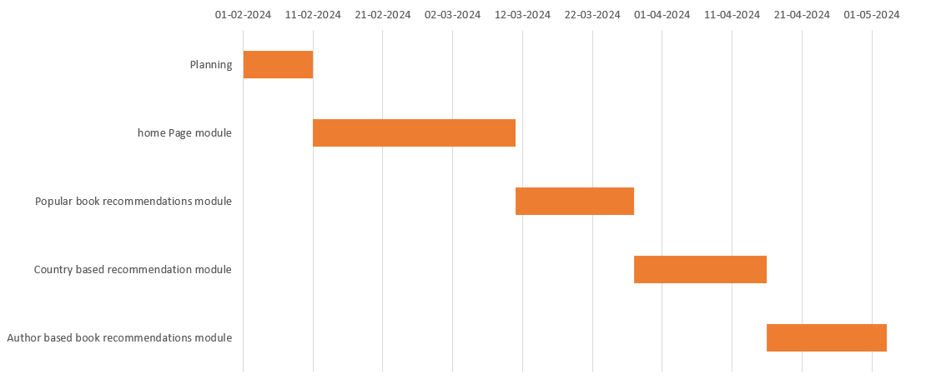

**Figure 14.1** Gantt Chart

# **CHAPTER 15**

# **FUTURE SCOPE OF THE PROJECT**

The future of the book recommendation system holds tremendous potential for growth and advancement, presenting numerous opportunities to enhance user experience and expand the system's capabilities. This chapter outlines key areas of development and innovation that will shape the evolution of the book recommendation system in the coming years.

**1. Enhanced Recommendation Algorithms:**

* Explore advanced machine learning techniques, such as deep learning and reinforcement learning, to develop more accurate and personalized recommendation algorithms.
* Incorporate contextual information, including user demographics, reading habits, and social interactions, to provide tailored book recommendations that resonate with individual preferences.

**2. Multi-modal Recommendations:**

* Integrate multi-modal content analysis capabilities to recommend books based on diverse formats, including text, audio, and video.
* Leverage natural language processing (NLP) and speech recognition technologies to analyze textual reviews, audiobook transcripts, and video content, enriching the recommendation process with multimedia insights.

**3. Collaborative Filtering and Social Recommendations:**

* Enhance collaborative filtering algorithms to leverage collective user behavior and preferences for generating more accurate recommendations.
* Incorporate social recommendation mechanisms, allowing users to discover books recommended by their social network connections, influencers, and trusted sources.

4. Real-time Recommendation Updates:

* Implement real-time recommendation updates to adapt to dynamic user preferences and evolving reading interests.
* Utilize streaming data processing techniques to continuously analyze user interactions and adjust recommendations in response to changing behavior patterns.

5. Personalized Reading Journeys:

* Develop personalized reading journey features that guide users through curated lists, reading challenges, and thematic book collections tailored to their interests and goals.
* Integrate progress tracking and achievement badges to incentivize user engagement and foster a sense of accomplishment in their reading journey.

**6. Accessibility and Inclusivity:**

* Prioritize accessibility features to ensure that the book recommendation system is usable and inclusive for users with diverse abilities and needs.
* Implement support for alternative formats, screen readers, and language translation services to enhance accessibility for all users.

**7. Cross-platform Integration:**

* Extend the reach of the book recommendation system by integrating with popular e-book platforms, online bookstores, and reading apps.
* Enable seamless synchronization of reading progress, recommendations, and bookshelf management across multiple devices and platforms.

**8. Data Privacy and Security:**

* Strengthen data privacy measures to protect user information and reading preferences from unauthorized access or misuse.
* Implement encryption protocols, access controls, and anonymization techniques to safeguard sensitive user data and uphold privacy regulations.

**9. Continuous Feedback and Improvement:**

* Establish mechanisms for collecting user feedback and ratings to iteratively improve recommendation algorithms and user experience.
* Leverage user engagement metrics and A/B testing frameworks to measure the effectiveness of new features and optimizations.

**10. Community Engagement and Content Curation:**

* Foster a vibrant community of readers and book enthusiasts through user-generated content, book clubs, and discussion forums.
* Empower users to contribute book reviews, ratings, and recommendations, enriching the platform with diverse perspectives and literary insights.

By embracing these future-oriented strategies and technologies, the book recommendation system can evolve into a dynamic and indispensable tool for readers worldwide, empowering them to discover, engage with, and share their love for literature in exciting new ways. Through ongoing innovation and collaboration with authors, publishers, and literary communities, the system will continue to redefine the landscape of digital reading and inspire a lifelong passion for books.

# **CHAPTER 16**

# **CONCLUSION**

The "Book Recommendation System" project epitomizes a groundbreaking venture at the nexus of literature and technology, poised to redefine how readers discover, engage with, and cherish books. Throughout the evolution of this project, we have embarked on a transformative journey to craft a sophisticated recommendation system capable of delivering personalized literary journeys with precision and insight. From the conceptualization phase to the deployment of advanced machine learning algorithms, our team has demonstrated unwavering dedication and creativity in tackling the intricate challenges of the literary world.

At its essence, "Book Recommendation System" embodies a commitment to harnessing state-of-the-art technologies, including artificial intelligence, natural language processing, and collaborative filtering, to empower readers with enriching literary experiences and curated recommendations tailored to their unique tastes and preferences. By leveraging the wealth of data and insights gleaned from readers' interactions and feedback, we have strived to enhance the serendipity and joy of literary discovery, fostering a deeper connection between readers and the vast universe of literature.

A pivotal achievement of the "Book Recommendation System" project lies in the development of advanced recommendation algorithms, which serve as a testament to the transformative potential of data-driven insights in the realm of literature. Through the application of cutting-edge machine learning techniques and collaborative filtering approaches, we have succeeded in building a robust recommendation engine capable of intuitively predicting readers' preferences and surfacing hidden literary gems. This breakthrough technology promises to revolutionize the way readers discover and engage with books, opening doors to new worlds of imagination and inspiration.

Furthermore, the expansion of the "Book Recommendation System" platform to encompass diverse genres, formats, and languages underscores our commitment to fostering inclusivity and diversity in the literary landscape. By embracing multi-modal recommendations and incorporating user-generated content, we aim to create a vibrant ecosystem where readers from all walks of life can explore, share, and celebrate their love for literature. Through ongoing innovation and collaboration with authors, publishers, and literary communities, we will continue to refine and enhance our recommendation algorithms to meet the evolving needs and aspirations of readers worldwide.

Beyond the technical achievements, the "Book Recommendation System" project embodies a broader vision of literary enrichment and community engagement, driven by a passion for storytelling and a commitment to fostering a lifelong love of reading. By nurturing a vibrant community of readers and fostering partnerships with authors, publishers, and literary organizations, we aim to cultivate a culture of curiosity, empathy, and imagination. Through initiatives such as virtual book clubs, author interviews, and literary events, we seek to inspire and connect readers, fostering a deeper appreciation for the transformative power of literature in our lives.

In conclusion, the "Book Recommendation System" project represents a pioneering initiative poised to redefine the future of reading and literary discovery. With its innovative technology, collaborative spirit, and unwavering dedication to reader-centric experiences, "Book Recommendation System" is poised to make a profound impact on the lives of readers, authors, and publishers alike. As we continue our journey of exploration and innovation, we remain steadfast in our commitment to igniting imaginations, fostering connections, and celebrating the timeless magic of storytelling in all its forms.

# **CHAPTER 17**

# **REFERENCES**

* Youtube.com
* Javatpoint.com
* openai.com
* [python.org](https://www.python.org/)
* [matplotlib.org](https://matplotlib.org/)
* [seaborn.pydata.org](https://seaborn.pydata.org/)
* [numpy.org](https://numpy.org/)
* [pandas.org](https://pandas.org/)
* kaggle.com
* streamlit.io